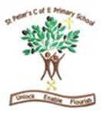

Year 5
Autumn Term 2 - 2025
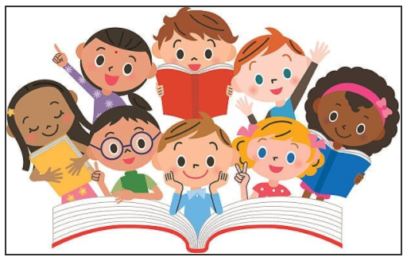
Spring 1 Learning – Year 5

Dear Parents and Carers,

Welcome to our latest Year 5 newsletter. We have an inspiring and varied half‑term ahead, filled with creativity, curiosity and new challenges.

English – Science Fiction
This half‑term, our writing focus is science fiction. We’ll be studying the classic story E.T. as inspiration for crafting our own imaginative narratives. Children will explore how authors build otherworldly settings, create believable characters and use suspense to keep readers hooked.

Maths – Multiplication and division B and Fractions B
This half term, Year 5 will also be working through two key White Rose Maths units: Multiplication B and Fractions B. These blocks build on previous learning and help pupils develop confidence, accuracy and flexibility when working with number.

In Multiplication B, children will focus on using efficient written methods to multiply larger numbers. They will apply their understanding of place value to support mental strategies and will tackle multi‑step multiplication problems set in real‑life contexts. Throughout the unit, pupils will be encouraged to explain their reasoning clearly and use precise mathematical vocabulary to deepen their understanding.

In Fractions B, pupils will continue to strengthen their knowledge of fractions by comparing and ordering them, finding equivalent fractions and adding and subtracting fractions with the same denominator. They will also solve a range of problems involving fractions, helping them apply their learning in meaningful situations. This unit supports later work on division, percentages and ratio by building secure foundational skills.

Science – Earth and Space
Our Science topic takes us on a journey beyond our planet as we investigate the movement of the Earth, Moon and Sun, explore how day, night and the seasons occur, and learn about the planets in our solar system. We will also look at how scientific understanding of space has changed over time. This unit is filled with awe, wonder and plenty of big questions to spark curiosity.

Geography – The Amazon Rainforest
In Geography, we’re travelling to South America to study the Amazon Rainforest, exploring biomes, its unique climate and incredible biodiversity. We will also learn about deforestation and the importance of environmental responsibility. This topic encourages children to think globally, act sustainably and begin to approach the world with the curiosity and questioning skills of real geographers.

Art- Rembrandt
Year 5 will be studying the famous Dutch artist Rembrandt, known for his powerful use of light and shadow. Children will explore how artists create mood, depth and focus by contrasting light and dark areas, a technique known as chiaroscuro. They will experiment with shading using pencils and charcoal, creating highlights and shadows, and observing how light falls on different objects. Using these skills, pupils will produce portraits inspired by Rembrandt’s dramatic style. This unit helps them develop greater control, precision and confidence in their drawing.

PSHE – How can we Help in an Emergency?
This unit teaches vital life skills as we learn how to recognise an emergency, stay calm and seek help, understand basic first aid principles, and know when and how to call for assistance. These lessons help build confidence, responsibility and the ability to respond safely in real‑life situations.

PE – Invasion Games- rugby & Dance
Our PE focus includes developing teamwork and strategy through invasion games, as well as building ball‑handling, passing and movement skills in rugby. Pupils will also learn about fair play, resilience and healthy competition. In Dance, we’ll explore the theme Earthlings, using movement to express ideas about humans, identity and our place in the world, with children experimenting creatively with choreography, rhythm and performance.

RE – Old Testament Women
Our RE learning includes a thought‑provoking question:
Old Testament women: Did she make the right choice? We’ll also explore key beliefs and practices within the Bible and look at women in Judaism, helping children understand different faiths and perspectives.

Thank you for your continued support. We look forward to a joyful and inspiring half term with your children!

Warm wishes,
Miss Rigby

