Whole Class Guided Reading Policy
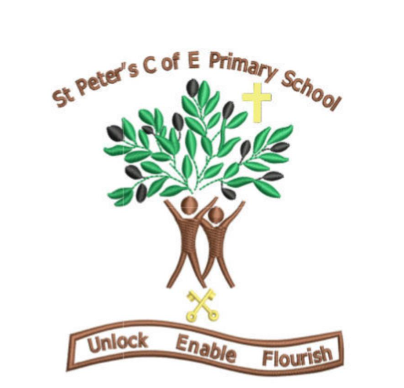
What do we do here?
At St Peter’s Primary School, we follow a whole class guided reading approach in line with National Curriculum aims and expectations. We do this to ensure all children receive quality first teaching and an adaptive approach for all children to fulfil their potential to become fluent readers and global citizens.
When does it take place?
In Key Stage One, all children follow the ‘Little Wandle’ scheme. In Key Stage Two, whole class guided reading takes place each day for 30 minutes.

Structure
Exploration of the text.
Every session begins with exploration of the text. The teacher will model read and then a mixture of shared reading, partner reading and choral reading takes place. It is important to note that during this time each child will be heard reading by their teacher. This allows for each teacher to formatively assess their class whilst checking for understanding to provide adaptive teaching strategies for each pupils’ needs.
. Vocabulary Check.
As a class we recap any new or unknown vocabulary to break it down so all children know the key words from the text. Pictures can be used in the process to make memorial links.

Questioning. Mixture of ‘Individual Thinking’ and ‘Partner Talk’.
During this lesson, these questions are posed to the children (see examples) and are discussed in pairs. Partner Talk is where children discuss their answers with their shoulder partner using the Oracy strands to justify their reasonings for each answer. Partner Talk promotes open ended questions and they’re not always being one interpretation. Individual Thinking is where the children are given a vocabulary, explain, statement, inference, retrieval question to reflect upon alone and then scribe down in their guided reading book. Children are then chosen at random to share their recorded thought using their Oracy skills. A lesson can involve a combination of ‘Individual Thinking’ and ‘Partner Talk’ questions to submerse the children into their class novels.
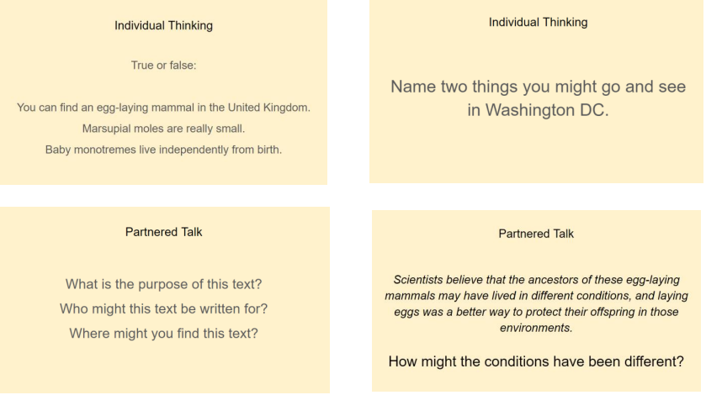
Solo Work.
The final session is the ‘Solo Work’ sections whereby the children produce a final answer or paragraph that summarises all the skills taught in that lesson. The Individual Thinking and Partner Talk questions will have been purposefully curated and scaffolded to lead to this outcome. A question is provided for the children that they can reflect on and provide detailed responses to. This can be in the form of a balanced argument, a summary, a prediction or an Oracy outcome (see example). The ‘Solo Work’ question is discussed as a class; modelled sentence stems can be shared by the teacher and the children complete their work independently in their books in full sentences using their best presentation.

