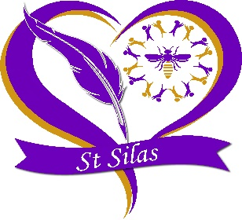

St. Silas’ CEP School Term and Holiday Dates for 2024 - 2025

Autumn Term

Training Day: Monday 2nd September 2024
Training Day: Tuesday 3rd September 2024
Reopen: Wednesday 4th September 2024
Training Day: Friday 18th October 2024
Mid-Term Closure: Monday 21st October 2024
Reopen: Monday 28th October 2024
Closure after school on: Friday 20th December 2024

Spring Term

Reopen: Monday 6th January 2025
Mid-Term Closure: Monday 17th February 2025
Reopen: Monday 24th February 2025
Closure after school on: Friday 4th April 2025

Summer Term

Reopen: Tuesday 22nd April 2025
Bank Holiday: Monday 5th May 2025
Mid-Term Closure: Monday 26th May 2025
Reopen: Monday 2nd June 2025
Closure after school on: Friday 18th July 2025
Training Day: Monday 21st July 2025
Training Day: Tuesday 22nd July 2025

