Emotional Health and Wellbeing
Support and Resources for Schools, Young People and Adults.

Resources to promote a whole school wellbeing culture:

- Better Health Every Mind Matters – School Zone. Download free PHSE resources from Public Health England to support work with 10-16 year olds on worry, self-care, sleep and more.

- The Critical Incident Team supporting schools/settings in the immediate aftermath of a critical incident. For further information, please contact the PEP: Anne.ford@blackburn.gov.uk

- DFE Website :
- DFE Blog post: How we’re helping look after the mental health of children and young people
- Mental health issues affecting a pupil's attendance: guidance for schools
- Practical materials for primary and secondary schools to use to train staff about teaching mental wellbeing.

- Education Psychology Team - The educational psychology team brings psychological knowledge, methods and tools to improve the development and wellbeing of children and young people.

- Health Visitors and School Nursing Teams for Blackburn with Darwen
- Healthy Child Programme - Be Well BWD
- School Nursing :: Lancashire and South Cumbria NHS Foundation Trust (lscft.nhs.uk)

- Mental Health Support Teams (MHST)
- Mental Health Support Teams (school-based) :: East Lancashire Hospitals NHS Trust (elht.nhs.uk)
- Requests for support via your Designated Mental Health Lead

- Online Safety
- NSPCC_online_abuse_and_bullying_prevention_guide_3.pdf (publishing.service.gov.uk)
This guide has been developed for professionals who work with young people to help them understand what constitutes abusive behaviour online, the consequences of that behaviour, and where they can get help. The guide applies to professionals working in England and Wales
- Professionals Online Safety Helpline - UK Safer Internet Centre Supporting professionals working with children and young people, with any online safety issue they may be having.
- https://www.safeguardingpartnership.org.uk/online/childrens-workforce/ Local Safeguarding Assurance Website – Section includes information and guidance to support colleagues across the children's workforce when addressing Online Safety for our Children and Young People.
- Staying Safe Lesson Plan Slides developed by City of York Safeguarding Partnership:
- Start Well - Be Well BWD Public Health Website. This contains information on local and national services that can help:

- Gambling | - Wellbeing
- Sexual Health | - Tobacco
- Mental Health | - Young Carers
- Drug and Alcohol Services | - ACEs

- Self-Harm Policy – This is a sample of a Self-Harm Policy for a Secondary School developed by Norfolk County Council Sample Self Harm Policy - Secondary Schools (norfolk.gov.uk)

- Special educational needs and/or disabilities: Local Offer
- Special educational needs and/or disabilities: Local Offer | Blackburn with Darwen Borough Council
- SEN and Disability | Blackburn with Darwen Local Offer (bwd-localoffer.org.uk)

- Suicide Safer Policy – Papyrus have produced a guide to support Schools develop their own policy. It illustrates each element to consider in a suicide safer policy, acknowledging what the school/college already does to prevent suicide, it outlines the schools/colleges intervention team and responsibilities and should it be needed, what to do in a postvention situation following a suicide. Download the guide: https://www.papyrus-uk.org/save-the-class/

- R;pple is an interceptive tool designed to present a visual prompt when a person searches for harmful keywords or phrases relating to the topic of self-harm or suicide on a computer. Free for schools. For more information or technical support email: luke@ripplesuicideprevention.com

- Training for all School Staff Members and Governors

Free Courses Available | Provider | For more Information
Mental Health First Aid  Youth Mental Health First Aid Course | BwD Adult learning Courses
Suicide First Aid  ASIST  safeTALK | Re-Align Futures CIC
Working with Self Harm | Lancs and South Cumbria Integrated Care Board | Contact Helen Parry:  Helen.parry17@nhs.net

- Wellbeing Champion - CANW are working with Secondary Schools across Blackburn with Darwen to train and support young people to become a peer mentor (or Wellbeing Champion) within their school. For more information contact: Huma Sheikh (hsheikh@canw.org.uk)

Support for Young People:
- ADHD Northwest - Offer support for children, young people and their families who are affected by ADHD. 01254 886886

- AMPARO - Offers support for anyone affected by suicide in Lancashire. 0330 088 9255.

- Be Well BwD For information and resources on improving your mental health from BwD’s Council Public Health Team. COMING SOON Bee - Yourself: A new resource for young people (Aged 8-11). This website has been designed to support children and young people's emotional health and wellbeing.

- Brook Blackburn - Free Sexual Health and Contraception Services - Brook Blackburn (sexualhealthblackburn.co.uk) Counselling offer is available. Brook ‘My Life’ offer; is an early help programme which aims to empower and support young people to improve their own health and wellbeing. 1-1 targeted support for young people – Brook

- Bullying and cyberbullying | Childline Information to support you, if you or someone you know is being bullied.

- Child Bereavement UK. Support for children and young people who are grieving. Helpline available: 0800 02 888 40

- ELCAS Young People’s Mental Health Drop – In Service. Every Wednesday. See poster below.

- Healthy Young Minds Online self-help materials, resources and guidance

- Kooth Safe and anonymous online counselling and support for young people. For more information or to order Kooth resources please email: hhook@kooth.com

- ORCHA Find and download NHS Approved APPS to your device to help improve and track your mental health and wellbeing.

- Papyrus HOPELINEUK. Support for young people dealing with suicide, depression or distress. Call on 0800 068 4141, or email pat@papyrus-uk.org or text 07860 039 967.

- Rainbow Youth Centre Acts as a hub for parents and young members of the LGBTQI+ community, a place that offers help, support, a place that is safe for young members be themselves.

- Reading Well for Teens This booklist is targeted at teenagers (13-18) and includes self-help techniques, personal stories, graphic books, fiction and a selection of supporting digital resources. Hard copies and online versions of these book are available from Blackburn Libraries service.
Blackburn Central Library | Blackburn with Darwen Borough Council

- Samaritans. To talk about anything that is upsetting you, you can contact the Samaritans, 24 hours a day, 365 days a year. Call 116 123 (free from any phone), or email jo@samaritans.org

- Trust House Provide specialist support services to women, men and children affected by rape and sexual abuse. They can also support the family. 01772 825288

- The Mix. If you’re under 25, you can call The Mix on 0808 808 4994 (Sunday-Friday 2pm–11pm)

Support for Adults (Parents and Staff)

- Bereavement Support Grief can be overwhelming. Call the Cruse helpline on 0808 808 1677.

- BwD Adult Learning provide training to help individuals and families on a range of wellbeing and mental health courses. Including Mental Health First Aid.

- Campaign Against Living Miserably (CALM). If you identify as male, you can call the Campaign Against Living Miserably (CALM) on 0800 58 58 58 (5pm–midnight every day) or use their webchat service.

- ELCAS Young People’s Mental Health Online Service. Every Wednesday. For adults concerned about someone under 18. See poster below.

- Flourishing Minds Lancashire Mind provide the following range of mental health and wellbeing services to ALL residents 18+:
- Wellbeing Workshops (One off workshops on topics including Five Ways to Wellbeing and stress management.)
- Wellbeing Groups (Completed over 6 weeks, covering topics such as low mood, anxiety, stress, sleep and worry management.)
- 1-to-1 Wellbeing Coaching (Work with a Wellbeing Coach over 6 sessions, to identify the challenges you are facing and look at ways to overcome them.)
To find out more contact: The Wellbeing Service on 01254 682037

- LSCFT (NHS) access urgent or general mental health support, 24 hours a day seven days a week. For you or for someone you are worried about. Call 0800 013 0707

- Manchester Parents Group is a voluntary organisation which supports families and friends of lesbian, gay, bisexual and transgender people (LGBT).

- NHS MENTAL HEALTH CRISIS LINE: If you need urgent help as you are in mental health distress and you are over 16 you can call 0800 953 0110 - 24 hours, seven days a week

- NHS Wellbeing Helpline & Texting Service: staffed by volunteers and those with lived experience, offers emotional support – ring if you want to chat about your mental health or are lonely etc. It can be contacted on 0800 915 4640 or by texting ‘Hello’ to 07860 022846.

- Online Safety
- Digital Parenting Pro | Parental Controls Guide | Vodafone UK – Help your family stay safe with the Digital Parenting website.
- Social media: How parents can limit its negative impact on mental health | Blogs | Anna Freud Centre
- How to Minimise the Impact of Social Media on Your Mental Health | Anna Freud Centre – Download the Managing Social Media Booklet

- ORCHA Find and download NHS Approved APPS to your device to help improve and track your mental health and wellbeing.

- Re-Align Futures CIC deliver fully funded training on a range of mental health topics – from awareness raising sessions through to accredited training courses on mental health and suicide intervention. (MHFA &ASIST) For more information: training@re-align.org.uk

- Samaritans. To talk about anything that is upsetting you, you can contact the Samaritans, 24 hours a day, 365 days a year. Call 116 123 (free from any phone), or email jo@samaritans.org

- SANEline. If you’re experiencing a mental health problem or supporting someone else, call 0300 304 7000 (4.30pm–10.30pm every day of the year).

- Trust House Provide specialist support services to women, men and children affected by rape and sexual abuse. They can also support the family. 01772 825288

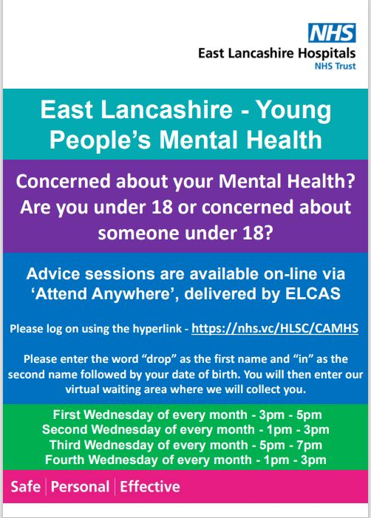
ELCAS Young People’s Mental Health Online Service.
Click on this link to access the sessions at the correct time each Wednesday:

Video call setup - Attend Anywhere

Following the instructions on the poster.

