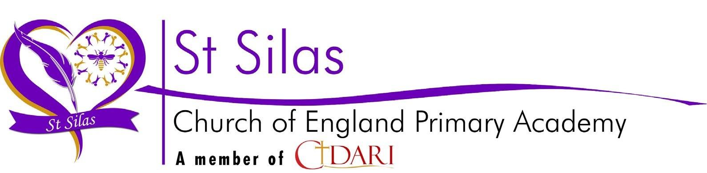

| Statutory consultation on proposed admission arrangements for ST SILAS CE PRIMARY SCHOOL FOR 2025/2026 |  |
| --- | --- |
| **From 30th November 2023 to 25th January 2024** |

## **Why are we consulting?**

## At least every 7 years, Admission Authorities must consult on their admission arrangements, even if there have been no changes during that period.

We would like your views on our admissions arrangements for St Silas Primary School for 2025/2026.

Admission Authorities must consult on proposed changes to its admission arrangements for a minimum of six weeks between 1 October (at the earliest) and 31 January (at the latest) in the determination year.

The consultation period for 2025-2026 admission arrangements for St Silas Primary School will run from Thursday 30th November 2023 to Thursday 20th January 2024.

## **What are we proposing to change and why?**

THERE ARE NO CHANGES TO OUR ADMISSIONS CRITERIA

## **Who are we consulting with?**

We are seeking views from:

1. Parents in our borough who have primary aged children.
2. Other persons in our borough who the Local Authority believes will have an interest in the proposed admissions.
3. All other admission authorities within the borough.
4. Governing bodies in the borough (who are not admission authorities);
5. Our adjoining/neighbouring local authorities where the admission authority.
6. The bodies representing the religions/religious denomination of the faith schools in our borough.

## **Consultation timetable**

| 30TH November 2023 | Consultation opens. |
| --- | --- |
| 25th January 2024 | End of consultation period and deadline for submitting responses to St Silas Primary School |
| Week commencing 29th January 2024 | Analysis of consultation responses and preparation of information to be considered by the governing body or trust. |
| 15 March 2024 | Publication of determined admission arrangements. |

## **How to respond**

This consultation will run from 30th November 2023 to 25th January 2024 (a period of six term time weeks, extra time has been added to account for the school holidays). You are invited to submit responses about the proposal above to St Silas CE Primary School by:

* + Online survey - please copy and paste this link into your browser https://docs.google.com/forms/d/1_3mejONYetS1Jg27yXMMsFmA3Dn7FKe1unIfwV_W82I/edit
  + Alternatively, download the consultation response form from <https://stsilasprimary.co.uk/key-information/admissions> and return via:
  + email [stsoffice@cidari.co.uk](mailto:stsoffice@cidari.co.uk) or
  + post – St Silas CE Primary School, St Silas Road, Blackburn BB2 6JP

Responses must be received no later than 5pm on Thursday 25th January 2024. Responses received after this time and date may not be considered.

## **For more information**

If you would like to discuss the proposal or would like more information, please email Mrs Battersby on michele.battersby@cidari.co.uk