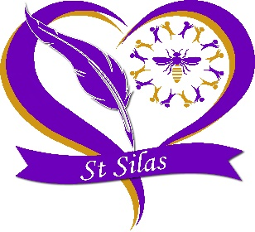

St. Silas’ CE Primary Academy School
Term and Holiday Dates for 2027 - 2028

Autumn Term

Training Day: Wednesday 1st September 2027
Reopen: Thursday 2nd September 2027
Training Day: Friday 22nd October 2027
Mid-Term Closure: Monday 25th October 2027
Reopen: Monday 1st November 2027
Closure after school on: Friday 17th December 2027

Spring Term

Reopen: Tuesday 4th January 2028
Mid-Term Closure: Monday 14th February 2028
Reopen: Monday 21st February 2028
Training Day: Will decide later on in the year
Closure after school on: Friday 31st March 2028

Summer Term

Training Day: Tuesday 18th April 2028
Reopen: Wednesday 19th April 2028
May Bank Holiday: Monday 1st May 2028
Mid-Term Closure: Monday 29th May 2028
Reopen: Monday 5th June 2028
Closure after school on: Thursday 20th July 2028
Training Day: Friday 21st July 2028

