**Main Christian Values**

* Faith
* Reverence
* Respect
* Wisdom

**Why is the Bible such a special book?**



New Testament

Old Testament

**Key Words**

**Bible**- A holy book for Christians

**Old Testament**- The first part of the Bible (before Jesus)

**New Testament**- The second part of the Bible (telling us all about Jesus)

**Holy**- something dedicated to God and very important

**Gospel**- The stories Jesus taught us

**Word of God**- Christians believe the Bible came from God

**Dead Sea scrolls**- Found a long time ago and have the Old Testament

For Christians the Bible is the most important book and it is the most treasured thing they own!

The Bible is a book that has 66 other books inside! It is full of lots of stories.

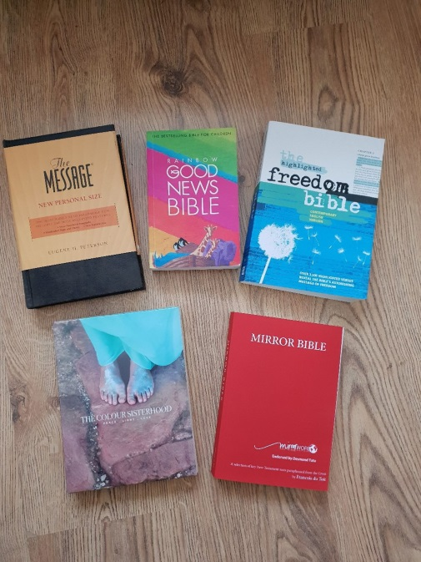

The Dead Sea Scrolls are ancient religious stories that are in the Bible!

Mary Jones saved for six years and walked 25 miles to own a Bible, why do you think she did that?