Key Information | Key Scientists | Subject Specific Vocabulary
Mammals - People are mammals. So are dogs, cats, bats, hedgehogs, dolphins and whales. If an animal drinks milk when it is a baby and has hair on its body, it belongs to the mammal class. | Carl Linnaeus (1707-1778)  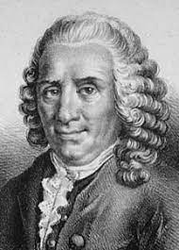  Carl Linnaeus was a Swedish botanist, zoologist and taxonomist who was famous for his work in Taxonomy: the science of identifying, naming and classifying organisms. His work is still used today.  Amy Vedder (1951-present)  Amy Vedder is a wildlife biologist, a scientist who studies animals and their behaviour. She uses her knowledge to save animals whose lives and habitats are threatened.  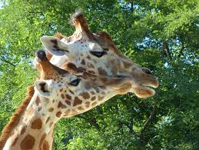 | carnivores | Animals that feed mainly on meat.  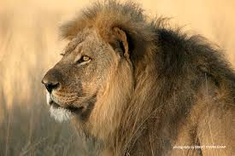
Birds are animals that have feathers and that are born out of hard-shelled eggs. |  | herbivores | Animals that mainly feed on plants.
Fish are vertebrates that live in water and have gills, scales and fins on their body. |  | omnivores | Animals that feed on both meat and plants.
Reptiles are a class of animal with scaly skin. They are cold blooded and are born on land. Snakes, lizards, crocodiles, alligators and turtles all belong to the reptile class. |  | vertebrates | Animals that possess a backbone or spinal column.
Amphibians are born in the water. When they are born, they breathe with gills like a fish. But when they grow up, they develop lungs and can live on land. |  | invertebrates | Animals that do not possess a backbone or spinal column.
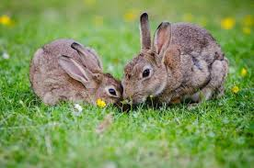 |  | 