Key Information | Key Scientists | Subject Specific Vocabulary
Material is not just fabric but all the ‘stuff’ in the world | John Boyd Dunlop (1840-1921)  John Boyd Dunlop was a Scottish inventor who was familiar with making rubber devices. He reinvented pneumatic tyres for his child’s tricycle and then developed them further for use in cycle racing.  Charles Macintosh (1766-1843)  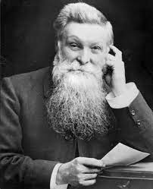  Charles Macintosh was a Scottish chemist who was best know for inventing waterproof fabric.  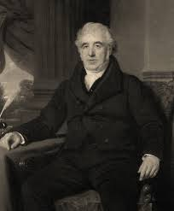  John McAdam (1756-1836)  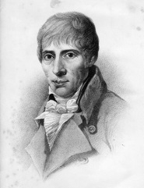  John McAdam was a Scottish engineer and road-builder. He was the inventor of the tarmacadam road surface. This created an effective and economical way to construct roads. | elastic (property) | Elastic materials can be stretched and when one stops pulling them, they return to their original shape
Solids, liquids and gases - All materials can exist in all states, dependent on temperature and pressure. |  | texture | The feel of a material is its texture. Smooth means that it doesn’t have lumps so things easy to slide. Rough means having a coarse, uneven surface. Sharp means have edges that are able to cut. Abrasive means that it will wear away other surfaces if rubbed against them.
Solids – These have a definite shape and keep it. |  | strength | A strong material is one that is difficult to break. In order to test strength we need to apply a force.
Liquids - Not all liquids are the same. They look and feel different. All liquids will pour. Thicker liquids pour more slowly. Liquids take the shape of their container. |  | Types of materials | wood, plastic, glass, metal, water, rock, brick, fabric, sand, paper, flour, butter, milk, soil
Gases - Gases will fill the space that they are in. If it is in a larger area the pressure will be less than if it were in a small area. |  | Properties of materials | hard/soft, stretchy/not stretchy, shiny/dull, rough/smooth, bendy/not bendy, transparent/not transparent, sticky/not sticky
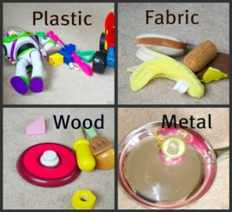 |  | Verbs associated with materials | crumble, squash, bend, stretch, twist
 |  | Senses | touch, see, hear, smell and taste

