Key Information | Key Scientists | Subject Specific Vocabulary
Plant Structure – In most plants the part above ground is the shoot system and the part below is the root system. | Gregor Mendel (1822-1884)  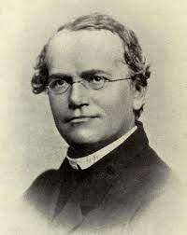  Gregor Mendel was an Austrian monk who was famous for carrying out experiments in his garden. Through his work on pea plants, he discovered laws of inheritance.  Carl Linnaeus (1707-1778)  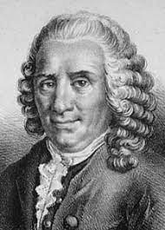  Carl Linnaeus was a Swedish botanist, zoologist and taxonomist who was famous for his work in Taxonomy: the science of identifying, naming and classifying organisms. His work is still used today.  George Forrest (1873-1932)  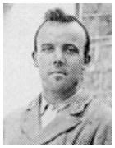  George Forrest was a Scottish botanist who became one of the first western explorers of China. He then introduced many plants from China into Europe. | deciduous | A tree or shrub that sheds its leaves annually.
The leaf – makes food for the plant by photosynthesis |  | evergreen | A tree or plant that has green leaves all year round.
The stem – supports the leaves and is part of the plant’s transport system. |  | name of trees | ash, birch, beech, rowan, oak, horse chestnut, sycamore, fir, pine and holly
Buds – are undeveloped shoots. Some buds produce flowers. |  | wild flowering plants | daisy, dandelion, coltsfoot, yarrow, spear thistle and white campion.
Roots – anchor the plant into whatever it is growing on or in. They also absorb water and other chemicals the plant needs to live. |  | garden plants | crocus, daffodils, bluebells
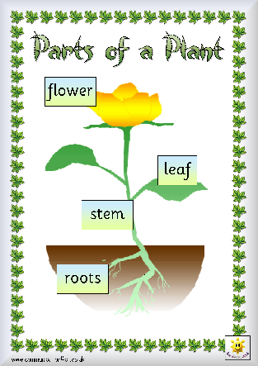 |  | 