Key Information | Key Scientists | Subject Specific Vocabulary
Spring – March to May | John Dalton (1766-1844)  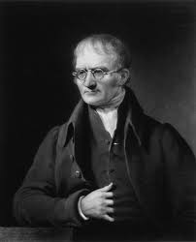  John Dalton was an English chemist, physicist and meteorologist. He was famous for the amount of time he kept a weather diary for.  Gabriel Fahrenheit (1686-1736)  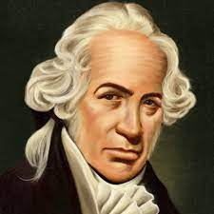  Gabriel Fahrenheit was a physicist, inventor and scientific instrument maker. He was famous for being the inventor of the first modern thermometer.  Inez Fung (1949-present)  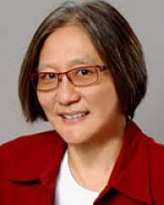  Inez Fung is a professor of atmospheric science at the University of California. She is famous for studying climate change. | spring | When the cold winter temperature gradually rise. It’s the time of new plant growth and when animals become active again.
Summer – June to August |  | summer | The hottest season of the year. The temperatures can stay warm even in the evening. Many trees and plants produce fruit during the summer.
Autumn – September to November |  | autumn | When the summer temperatures gradually decrease. Autumn is a time of change when leaves can change colour and fall from the trees. Animals also begin to prepare for winter.
Winter – December to February |  | winter | The coldest time of year when tress and other plants stop growing. Many animals hibernate during this season. Nights are longer during the winter.
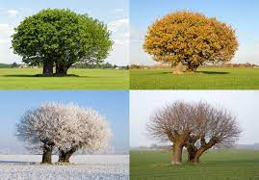 |  | temperature  year  day  month | It’s the measure of how hot or cold something is. It can be measured using a thermometer and is measured in degrees Celsius or Fahrenheit.  365 days or 366 days in a leap year.  24 hours.  A period of time of approx. 4 weeks. There are 12 months in a year.
 |  | weather vane | A device to show which way the wind is blowing.

