Key Information | Key Scientists | Subject Specific Vocabulary
Food Chains – All living things need energy, they get this energy from food. A food chain shows how energy is passed between plants and animals. | Chris Packham (1961-present)  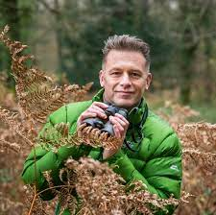  Chris Packham is an English naturalist, nature photographer, television presenter and author, best known for his television work including the CBBC children's nature series.  Kate Humble (1968-present)  Kate Humble is an English television presenter and narrator, mainly working for the BBC, specialising in wildlife and science programmes.  Steve Backshall (1973-present)  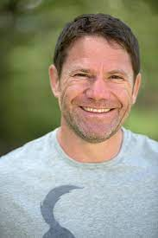  Steve Backshall is a BAFTA-winning English naturalist, explorer, writer and television presenter, best known for BBC TVs Deadly 60. His other BBC work includes being part of the expedition teams in Expedition with Steve Backshall, Lost Land of the Tiger, Lost Land of the Volcano, Deadly Dinosaurs and Lost Land of the Jaguar. | habitat | Habitats are places where animals and plants live
Producers are usually plants in a food chain as they have the ability to make their own food. |  | micro-habitat | A micro-habitat is a small-scale specific habitat which supports the survival of certain animals or plants. For instance, a rock pool or a rotting log.  A micro-habitat will differ from the larger environment around it, making it particularly suited to one or more species.
Plants make their own food using sunlight, water and air. |  | organism | An organism is an individual animal, plant, or single-celled life form.
Primary consumers – feed on plants for energy (herbivores) |  | habitats | pond, meadow, log pile, woodland, river, lake, beach, cliff
Secondary consumers – feed on plants and animals for energy (carnivores and omnivores) |  | pond animals | pond skater, Ramshorn snail, pond snail, leech, common frog, newt
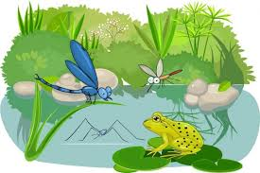 |  | invertebrates | snail, slug, woodlouse, spider, beetle, fly etc.
 |  | 