Key Information | Key Scientists | Subject Specific Vocabulary
Plant Structure – In most plants the part above ground is the shoot system and the part below is the root system. | Gregor Mendel (1822-1884)  Gregor Mendel was an Austrian monk who was famous for carrying out experiments in his garden. Through his work on pea plants, he discovered laws of inheritance.  Barbara McClintock (1902-1992)  Barbara McClintock won the Nobel prize for her work in genetics. She carried out similar studies to Gregor Mendel and tracked how characteristics  were inherited in maize. She then made links to inheritance in plants.  Joseph Banks (1743-1820)  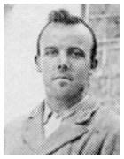  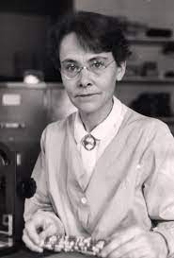  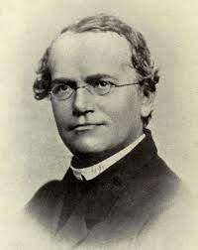  Joseph Banks was a scientist and explorer who was famed for introducing many plant species to the Western world. He accompanied famous explorers such as Captain Cook on their travels to make these discoveries. | deciduous | A tree or shrub that sheds its leaves annually.
The leaf – makes food for the plant by photosynthesis |  | evergreen | A tree or plant that has green leaves all year round.
The stem – supports the leaves and is part of the plant’s transport system. |  | name of trees | ash, birch, beech, rowan, oak, horse chestnut, sycamore, fir, pine and holly
Buds – are undeveloped shoots. Some buds produce flowers. |  | wild flowering plants | daisy, dandelion, coltsfoot, yarrow, spear thistle and white campion.
Roots – anchor the plant into whatever it is growing on or in. They also absorb water and other chemicals the plant needs to live. |  | garden plants | crocus, daffodils, bluebells
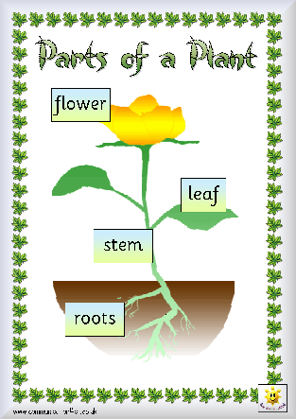  Needs of plants – water, light, heat and temperature |  | 