Key Information | Key Scientists | Subject Specific Vocabulary
Material is not just fabric but all the ‘stuff’ in the world | Leo Hendrik Baekeland (1863-1944)  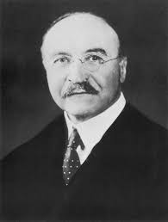  Leo Hendrik Baekeland was a chemist, manufacturer and inventor who invented Bakelite, the first plastic to be used widely in industry.  Charles Goodyear (1800-1860)  Charles Goodyear was an American inventor who experimented with, perfected, and promoted the use of rubber.  Prof Frances M Ross (present)  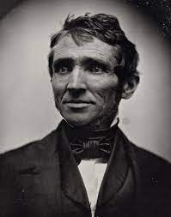  Frances Ross is a Professor in Materials Science and Engineering. She has won many awards over the years for her investigations into the growth of materials. | elastic (property) | Elastic materials can be stretched and when one stops pulling them, they return to their original shape
Solids, liquids and gases - All materials can exist in all states, dependent on temperature and pressure. |  | texture | The feel of a material is its texture. Smooth means that it doesn’t have lumps so things easy to slide. Rough means having a coarse, uneven surface. Sharp means have edges that are able to cut. Abrasive means that it will wear away other surfaces if rubbed against them.
Solids – These have a definite shape and keep it. |  | strength | A strong material is one that is difficult to break. In order to test strength we need to apply a force.
Liquids - Not all liquids are the same. They look and feel different. All liquids will pour. Thicker liquids pour more slowly. Liquids take the shape of their container. |  | Types of materials | wood, plastic, glass, metal, water, rock, brick, fabric, sand, paper, flour, butter, milk, soil
Gases - Gases will fill the space that they are in. If it is in a larger area the pressure will be less than if it were in a small area. |  | Properties of materials | hard/soft, stretchy/not stretchy, shiny/dull, rough/smooth, bendy/not bendy, transparent/not transparent, sticky/not sticky
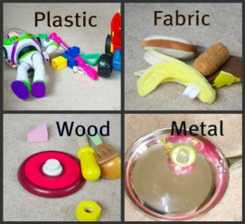 |  | Verbs associated with materials | crumble, squash, bend, stretch, twist
 |  | Senses | touch, see, hear, smell and taste

