Key Information | Key Scientists | Subject Specific Vocabulary
The key to a healthy balanced diet is:  - Eating the right amount of food for how active you are  - Eating a range of foods | Diane France (1954-present)  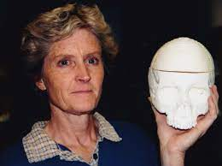  Diane France also known as the bone detective is a forensic anthropologist. She loves bones and can solve mysteries and crimes by working out the stories that the bones tell her.  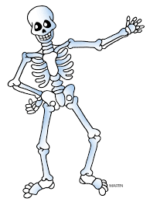 | nutrition  diet | Nutrition is the study of food and how it works in your body. Nutrition includes all the stuff that's in your food, such as vitamins, protein, fat, and more.  A diet contains differing kinds of foods in certain quantities and proportions so that your body had the correct requirements.
Your diet should include:  Fruit and veg, carbohydrates, dairy, protein and a small amount of fats and sugar. |  | carbohydrates | Bread, cereals, pasta, rice, and sweet foods are mostly carbohydrates. You need them to give you energy.
Skeletons helps us to move (movement) |  | dairy | Dairy, like milk, cheese and yoghurt, gives us calcium for strong teeth and bones.
Skeletons help to protect vital organs like the brain and heart (protection) |  | protein | Your muscles, your organs, and your immune system are made up mostly of protein. You'll find protein in lots of yummy foods like eggs, nuts, beans, fish, meat, and milk.
Skeletons provide our bodies with support |  | fats | The body uses fat as a fuel source. Some examples of foods that contain fats are butter, oil, nuts, meat, fish, and some dairy products. These should be consumed in small amounts.
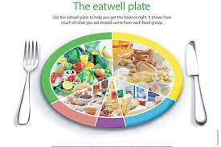 |  | 