Key Information | Key Scientists | Subject Specific Vocabulary
Not all metals are attracted to magnets – only those containing iron, steel and nickel. | William Gilbert (1544-1603)  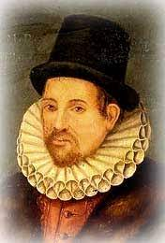  William Gilbert was an English scientist and physician who is credited by many as the “father of electricity and magnetism”. When he observed that magnetic forces often produced circular motions, he began to connect the phenomenon of magnetism with the rotation of the earth.  Hans Christian Oerstad (1777-1851)  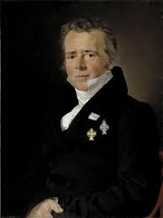  Hans Christian Oerstad was a Danish physicist and chemist who discovered that electric currents create magnetic fields, which was the first connection found between electricity and magnetism. | magnets | Magnets are objects that are made of materials that create a magnetic field.  There are different types of magnets e.g. bar, horseshoe etc. They can have varying magnetic strengths.
Magnets have two poles, a north and a south pole. The pole is where the pull of the magnet is the strongest. |  | attract | A pull force by the magnet’s magnetic field. Opposite poles will attract each other.
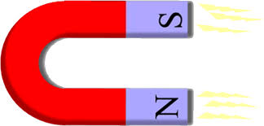 |  | repel | A push force by the magnet’s magnetic field. Like poles will repel each other (push each other away).
 |  | north and south poles | The ends of the magnets where the pull of the magnet is the strongest. When opposite poles are near to each other they will attract, whereas when the same poles are near to each other, they will repel,
 |  | magnetic | Possessing the power or ability to attract or repel certain substances.
 |  | magnetic field | An area around a magnet in which there is a magnetic force.
 |  | 