Key Information | Key Scientists | Subject Specific Vocabulary
Light source – places/objects from which light is emitted e.g. sun, candles, torches. | James Clerk Maxwell (1831-1879)  James Clerk Maxwell was one of the greatest scientists who have ever lived. To him we owe the most significant discovery of our age - the theory of electromagnetism. Without his work, we wouldn’t have televisions, radios, microwaves etc.  Thomas Young (1773-1829)  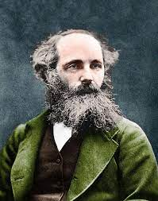  Thomas Young was an English physician and physicist who was one of the first scientists to understand how light worked.  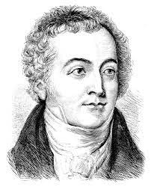  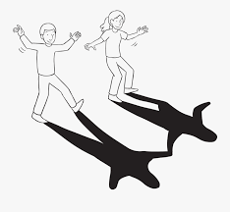 | transparent | When light can completely pass through an object and you can clearly see through it.
Formation of shadows – light travels in a straight line. If an opaque object gets in the way, it stops light from travelling through it. This results in an area of darkness behind the object. |  | translucent | When some light can pass through and object. The light is scattered so you cannot see clearly through it.
The moon – is NOT a light source because it does not produce its own light. |  | opaque | When light cannot pass through an object so you cannot see through it.
Artificial (manmade) – made or caused by human  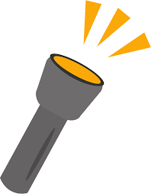  Natural – existing or obtained from nature |  | reflection | When light from an object is reflected by a surface, it changes direction. It bounces off the surface at the same angle as it hits it.  Smooth, shiny surfaces such as mirrors and polished surfaces reflect light well. Dull, dark surfaces such as dark fabrics do not reflect light well.
 |  | refraction | When light travels from air through water, glass or anything that lets light through, it gets bent. This bending is called refraction.

