Key Information | Key Scientists | Subject Specific Vocabulary
Types of teeth:  - incisors - at the front of the mouth with a thin top edge, used for biting into things and chewing  - canines – sharp pointy teeth used for tearing and ripping food  - Premolars – bigger, ridged teeth next to canine teeth that are stronger than incisors and canines. They crush and grind up food.  - Molars – flat teeth near the back of the mouth. They crush and grind up food. | Al-Jahiz (9th century)  Al-Jahiz was a Muslim writer from Basra in Iraq. Even though his family was poor, he always sought out knowledge on lots of topics. He wrote over 200 books, the most famous was Book of Animals that described the mechanics of evolution 1000 years before Darwin did!  Charles Elton (1900-1991)  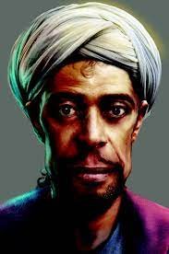  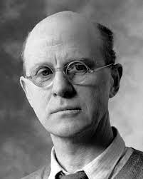  Charles Elton was an English zoologist and animal ecologist. He is associated with the development of population and community ecology.  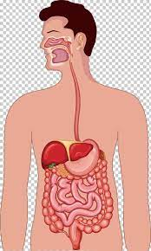 | carbohydrates  protein  fats | Bread, cereals, pasta, rice, and sweet foods are mostly carbohydrates. You need them to give you energy.  Your muscles, your organs, and your immune system are made up mostly of protein. You'll find protein in lots of yummy foods like eggs, nuts, beans, fish, meat, and milk.  The body uses fat as a fuel source. Some examples of foods that contain fats are butter, oil, nuts, meat, fish, and some dairy products. These should be consumed in small amounts.
The digestive system uses the oesophagus, stomach, acid and the small intestine to break down food into other substances that our bodies can use. |  | dairy | Dairy, like milk, cheese and yoghurt, gives us calcium for strong teeth and bones.
Food Chains – All living things need energy, they get this energy from food. A food chain shows how energy is passed between plants and animals. |  | saliva | Saliva is none other than spit, the clear liquid in your mouth that's made of water and other chemicals. Saliva helps keep the mouth moist and contains an enzyme that starts to break down food even before it hits your stomach!
 |  | producers | These are usually plants in a food chain as they have the ability to make their own food.
 |  | primary consumers | Organisms that feed on plants for energy (herbivores)
 |  | secondary consumers | Organisms that feed on plants and animals for energy (carnivores and omnivores)

