Key Information | Key Scientists | Subject Specific Vocabulary
What is a circuit? – It is a complete path around which electricity can flow. | Alessandro Volta (1745-1827)  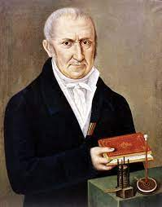  Alessandro Volta was an Italian physicist, chemist, and pioneer of electricity and power who is credited as the inventor of the electric battery and the discoverer of methane.  Andre-Marie Ampere (1775-1836)  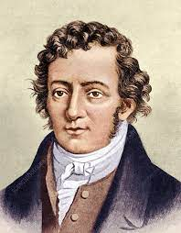  André-Marie Ampère was a French physicist and mathematician whose studies allowed people to measure the amount of electrical current flowing through a circuit. The current is measured in units called amperes or amps for short.  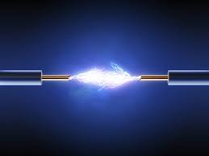 | electricity | Electricity is a form of energy. Energy is needed to make things happen.
What does a circuit need to work? – It must have a power supply (a battery). The positive and negative ends of the battery must be connected using wires.  A simple circuit can be made from a battery, a bulb and wires |  | components  effects of electricity | battery, bulb (lamp), bulb holder, buzzer, crocodile clip, leads, wires, switch  light, sound, movement, heat
What does a switch do? - Switches are used to control circuits. They can break a circuit (when open) so switch a bulb, buzzer or motor off or complete a circuit (when closed) and switch them on again. |  | electrical conductor | Materials that let electricity to pass through them. Metals such as copper, iron and steel are good conductors.
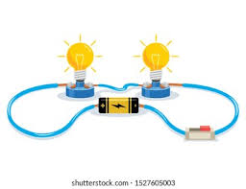 |  | electrical insulator | Materials that do not allow electricity to pass through them. Plastic, wood, glass and rubber are good insulators.
 |  | Appliances | fridge, freezer, TV, computer, iron, kettle etc
 |  | 