Key Information | Key Scientists | Subject Specific Vocabulary
Food Chains – All living things need energy, they get this energy from food. A food chain shows how energy is passed between plants and animals. | Carl Linnaeus (1707-1778)  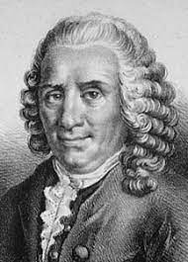  Carl Linnaeus was a Swedish botanist, zoologist and taxonomist who was famous for his work in Taxonomy: the science of identifying, naming and classifying organisms. His work is still used today.  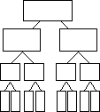 | habitat | Habitats are places where animals and plants live
Producers are usually plants in a food chain as they have the ability to make their own food. |  | micro-habitat | A micro-habitat is a small-scale specific habitat which supports the survival of certain animals or plants. For instance, a rock pool or a rotting log.  A micro-habitat will differ from the larger environment around it, making it particularly suited to one or more species.
Plants make their own food using sunlight, water and air. |  | organism | An organism is an individual animal, plant, or single-celled life form.
Primary consumers – feed on plants for energy (herbivores) |  | habitats | pond, meadow, log pile, woodland, river, lake, beach, cliff
Secondary consumers – feed on plants and animals for energy (carnivores and omnivores) |  | pond animals | pond skater, Ramshorn snail, pond snail, leech, common frog, newt
Classification – Animals can be divided into groups or ‘classified’ by looking at the similarities and differences between them.  Animals are divided into 2 main groups, vertebrates and invertebrates. They are then divided into smaller groups for example; vertebrates are divided into fish, birds, reptiles and mammals. |  | invertebrates | Animals that do not have a backbone inside their body. They have a soft body like worms and jellyfish, or a hard outer casing covering their bodies like crabs and spiders.
 |  | vertebrates | Animals that have a backbone inside their body e.g. fish, amphibians, reptiles, birds and mammals.
 |  | 