Key Information | Key Scientists | Subject Specific Vocabulary
What is sound? – Sound is made when objects vibrate. The vibrations enter your ear and you hear them as sound. | Ernst Mach (1838-1916)  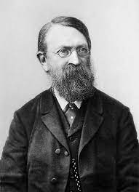  Ernst Mach was an Austrian physicist and philosopher, noted for his contributions to physics such as the study of shock waves. He also invented ways of measuring sound waves.  Heinrich Hertz (1857-1894)  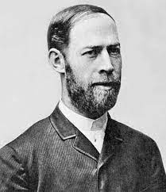  Heinrich Hertz was a German physicist who first conclusively proved the existence of the electromagnetic waves. The unit of frequency was named the "hertz" in his honour.  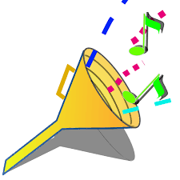 | pitch | The pitch of a sound is how high or low the sound is.
Reflection of sound – Sound waves can reflect off surfaces. We hear reflections as echoes. Hard, smooth surfaces are good at reflecting sound which is why empty rooms often produce lots of echoes. |  | vibrations | Vibration means quickly moving back and forth (or up and down). Something that is vibrating may also shake at the same time. Vibrations may be periodic (have a pattern) or random.
Absorption of sound –Sound waves do not reflect off soft, rough surfaces such as carpets and curtains. This results in the loss of sound and no echoes. |  | volume | The volume of a sound is how loud or quiet the sound is. A strong vibration will make a loud sound; a weaker vibration will make a quieter sound.
What sounds can travel through – sounds travel faster in water and slower in the air. Sounds travel more quickly through solids and liquids than through gases. |  | sound waves | Sound is made up of vibrations or sound waves. Sound waves are formed by objects vibrating.
 |  | ways to create sound | bang, blow, shake, pluck

