Key Information | Key Scientists | Subject Specific Vocabulary
The water cycle (1) – is a continuous journey of water from oceans and lakes to clouds, to rain, to stream and rivers and then back into the ocean. | Alfred Barnhard Nobel (1833-1896)  Alfred Barnhard Nobel was famous for his working with liquids such as nitro-glycerine to see how they could be controlled. He later invented dynamite and was the benefactor of the Nobel Prizes.  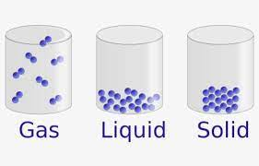  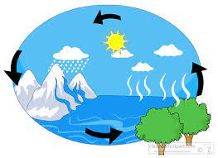 | melting | If a solid is heated, it changes to a liquid. E.g. ice to water
The water cycle (2) – follows a cycle of evaporation, condensation, precipitation and collection (see vocabulary section) |  | condensation | If a gas like water vapour is cooled down, it changes back into a liquid (water).
Solids – A solid has a fixed shape and cannot flow like a liquid. It stays in one place and can be held easily. They always take up the same amount of space and do not spread out like gases. Solids can be cut or shaped. Examples are wood, rocks, metal and glass. |  | evaporation | If a liquid like water is heated, it changes to a gas (water vapour).
Liquids – A liquid can flow and be poured easily. They are not easy to hold and they change shape depending on the container. The volume always stays the same. Examples are water, milk, juice and oil. |  | freezing | If a liquid is cooled, it changes to a solid. E.g. water to ice
Gases – They do not have a fixed shape and are often invisible. Gases spread out and change their shape and volume to fill whatever container they are in. Gases can be squashed. Examples are oxygen, hydrogen, helium and carbon dioxide |  | steam | Another word for water vapour, the gaseous state of water.
 |  | precipitation | The release of water from the sky. It can be liquid or solid, for example, rain, sleet, snow and hail.
 |  | states of matter | solids, liquids, gases

