Key Information | Key Scientists | Subject Specific Vocabulary
Puberty - Puberty is the stage in life when a child's body develops into an adult's body. The changes take place gradually, usually between the ages of 10 and 16. Changes occur at puberty because of hormones. | Professor Robert Winston (1940 -present)  Professor Robert Winston is a contemporary scientist famous for his studies on humans. In particular, his long term televised observations on children throughout their lives.  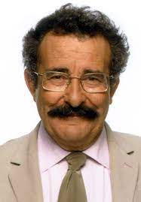  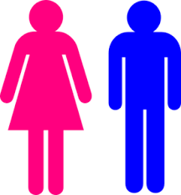 | baby  toddler | A very young child from birth - 1 years of age.  A young child from ages 1 – 3 years of age.
Hormones - Hormones are chemicals that tell cells and body parts to do certain things. For example, hormones tell the body when to grow and when to stop growing. In humans and other animals, organs called glands release hormones into the blood. Together these glands make up the endocrine system. |  | child  adolescent/teenager  adult | A child from ages 3 - 12 years of age.  A child from ages 13 - 18 years of age.  A person from ages 18 – 65 years of age.
Oestrogen - Oestrogen (or estrogen) is a group of female hormones. |  | elderly person | A person from age 65 years +
Testosterone – Testosterone is a group of male hormones. |  | gestation | Gestation is the period of time that a mammal carries her offspring, or babies, inside her body before giving birth. The length of gestation is different for each type of mammal. Larger animals usually have longer gestations than smaller animals.
Getting Older - As you get older, your skin wrinkles because it becomes thinner and less elastic. It gets drier too as it makes less oil and sweat. Your bones become more visible as you store less fat beneath your skin. Inside the body your bones and muscle become weaker. Your memory gets worse, and your immune system cannot fight disease as easily. |  | 