Key Information | Key Scientists | Subject Specific Vocabulary
Day and Night - The Earth rotates one complete turn every 24 hours to give us day and night. When Britain faces the Sun it is daytime in Britain but the other side of the world is in darkness. So, in Australia it is the middle of the night. | Aristarchus (310 -230 BC)  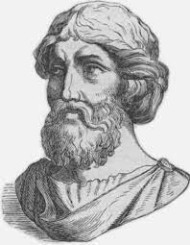  Aristarchus was the first person to figure out that the Earth travels around the sun and not vice versa.  Nicolas Copernicus (1473-1543)  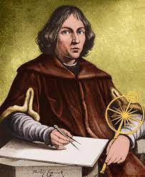  Nicolas Copernicus had the idea that the Earth revolves on its axis and the Earth and other planets orbit around the Sun.  Galileo Galilei (1564-1642)  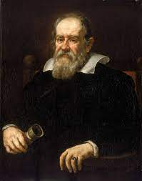  Galileo Galilei was the first person to make a study of the skies with a telescope.  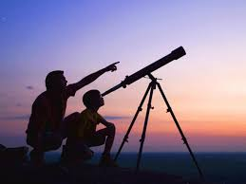 | axis | The axis is the imaginary line through the earth that extends from the North Pole to the South Pole. As Earth rotates, it seems like the sun is moving across the sky, but it's really the Earth that is spinning. It takes 24 hours to complete one rotation, which is why there are 24 hours in one day.
Phases of the moon - The phases of the Moon are the different ways the Moon looks from Earth over about a month.  As the Moon orbits around the Earth, the half of the Moon that faces the Sun will be lit up. The different shapes of the lit portion of the Moon that can be seen from Earth are known as phases of the Moon. Each phase repeats itself every 29.5 days. |  | rotate  The planets | A rotation is a turn of a shape (the Earth rotates or spins).  The planets in order from nearest to the Sun are: Mercury, Venus, Earth, Mars, Jupiter, Saturn, Uranus and Neptune. (Pluto has been downgraded to a dwarf planet and is no longer in the list.)  The order can be remembered using the mnemonic: My Vicious Earthworm Might Just Swallow Us Now
How long does it take the earth to orbit the sun? 365 $\frac{1}{4}$ days so every four years there is a leap year with 366 days (29th February) |  | solar system | The Solar System is made up of the Sun and all of the smaller objects that move around it. Apart from the Sun, the largest members of the Solar System are the eight major planets.
How long does it take the moon to orbit earth? One lunar month (see vocab list) |  | sphere | A sphere is a perfectly-round 3D shape in the shape of a ball. The Earth is an approximate sphere (not a perfect sphere).
How long does it take the earth to complete one rotation (spin) on its axis? 24 hours  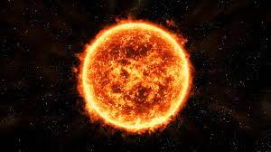 |  | lunar month | A lunar month is the amount of time it takes for the Moon to pass through each of its phases (new moon, half, full moon), and then return back to its original position.
 |  | orbit | An orbit is the path that an object takes in space when it goes around a star, a planet, or a moon. For instance: “The earth orbits around the Sun.”
 |  | Sun | The Sun is a star that is in the centre of the solar system. The planets all orbit the sun. The Sun’s force of gravity ensures the planets orbit at the correct distance and speed.

