Key Information | Key Scientists | Subject Specific Vocabulary
Gravity - Gravity is the name for a force that pulls everything down toward the centre of the Earth. Gravity also pulls any object with mass toward each other. E.g. the Earth and the Moon or the Moon and the Sun. | Sir Isaac Newton (1642-1727)  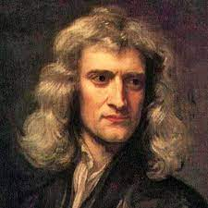  Sir Isaac Newton was born in England on the 12th of February 1809; he died on the 19th of April 1882. He is most famous for his work on natural selection, the idea that all species of life have evolved over time from common ancestors.  Archimedes (c.287- c.212 BC)  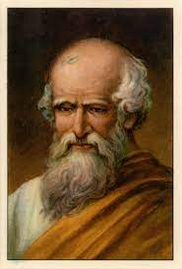  Archimedes was born in Wales on 8th January 1823; he died on 7th November 1913. He is best known for proposing a theory of natural selection. This was published in 1858 together with Charles Darwin's idea.  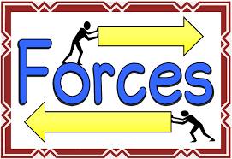 | Newton/Newton Meter  particles | Forces are measured in Newtons (N) using a Newton metre. 100g = 1N, 1g = 0.01N and 1kg = 10N  A particle is something that is so tiny we can't see it.
Friction - Friction is a force between two surfaces that are sliding, or trying to slide, across each other. For example, when you try to push a book along the floor, friction makes this difficult.  Friction always works in the direction opposite to the direction in which the object is moving, or trying to move.  Friction always slows a moving object down  Weight - Weight is the measure of the force of gravity on an object. |  | push/pull  balance  levers | A push is the force that moves an object away from something. /  When force brings an object closer, that is a pull.  Balance is where two forces of equal size, act on a body, in opposing directions is known as a Balanced Force.  A lever is a simple machine. It is something that can be used in a lot of ways. One way is by measuring things, or by seeing which weighs more. A lever is supported by a fulcrum which it uses to lifts weights.
Air resistance - Air resistance is a kind of friction that occurs between air and another object. It is the opposing force that the object experiences as it passes through the air.  Upthrust - Upthrust is the force that pushes an object up. and makes it seem to lose weight in a fluid. (Remember, a fluid means a liquid or a gas). The upthrust, or buoyancy, keeps ships afloat. The upthrust, or buoyancy, keeps swimmers on top of the water. |  | gears  pulleys | Gears are wheels with teeth that slot together. When one gear is turned the other one turns as well. If the gears are of different sizes, they can be used to increase the power of a turning force. The smaller wheel turns more quickly but with less force, while the bigger one turns more slowly with more force.  A pulley is simply a collection of one or more wheels over which you loop a rope to make it easier to lift things.
Surface Area - Surface area is a measurement of all the space that the surface of a three-dimensional shape takes up (with a three-dimensional shape being a shape with height, width, and depth). In other words, surface area is the total of all the areas of each of the sides of an object. |  | springs | A spring is a coiled piece of metal, usually steel, that stores energy. The word spring can also be used for any elastic object that stores energy, such as a rubber band. The stored energy can be used to create push and pull forces.

