Key Information | Key Scientists | Subject Specific Vocabulary
Life cycles – A life cycle is the different stages of life for a living thing. In science it is usually displayed as a circular diagram showing each stage in words and/or pictures. A life cycle is presented as a circle to show that seeds / offspring are created as part of the cycle. | Berry J Brosi (present)  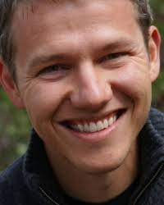  Berry J Brosi, an assistant professor at a university in Atlanta, found that a loss of bees affects a plant’s ability to reproduce.  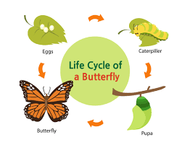  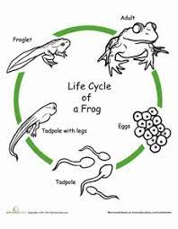 | animals | amphibians, reptiles, birds, mammals, insects, fish
 |  | egg | An egg is a single female germ cell, or reproductive cell.
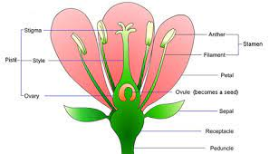  Parts of a Plant  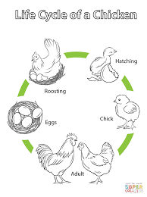 |  | nymph | A nymph is the immature form of some invertebrates, particularly insects, which undergoes metamorphosis.
 |  | adult | A fully grown person, animal, or plant.
 |  | metamorphosis | Metamorphosis is a process some animals go through to become adults. It is a series of physical changes. An example is a caterpillar turning into a butterfly.
 |  | pollination | Pollen is carried by insects or blown by the wind from one flower to another. This process is called pollination. Pollen reaches the new flower and travels to the ovary where it fertilises egg cells (ovules) to make seeds.
 |  | fertilisation | In plants, fertilisation occurs after pollination. This involves pollen grains from the male anther of a flower being transferred to the female stigma.
 |  | germination | Germination is the process by which seeds begin to grow into plants.  