Key Information | Key Scientists | Subject Specific Vocabulary
Thermal conductors – Heat passes easily through some materials. These are called thermal conductors. Metals like copper, aluminium and gold are great thermal conductors. | Marie Curie (1867-1934)  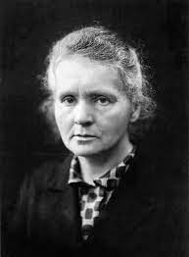  Marie Curie was a physicist and chemist who conducted pioneering research on radioactivity. She is remembered for her discovery of radium and polonium, and her huge contribution to finding treatments for cancer.  John Dalton (1766-1844)  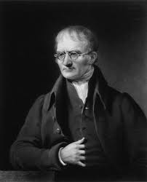  John Dalton was an English chemist, physicist and meteorologist. He was famous for the atomic theory that suggested all matter was comprised of atoms.  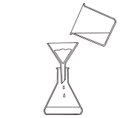 | dissolving | Some substances dissolve when you mix them with water. When a substance dissolves, it might look like it has disappeared, but in fact it has just mixed with the water to make a transparent liquid called a solution.
Thermal insulators – Heat does not pass easily through some materials so we can use them to keep things hot or cold instead e.g. flasks, polystyrene. |  | solvent | A liquid that will dissolve something is called a solvent.
Electrical conductors - Electricity passes easily through some materials. These are good electrical conductors e.g. copper, aluminium. |  | solution | When a substance dissolves in water to make a transparent liquid, it is called a solution.
Electrical insulators - Electricity does not pass easily through some materials. These are good electrical insulators e.g. wood, plastic. |  | soluble/insoluble | when mixed with water, it disappears (dissolves)/when mixed with water, it doesn’t dissolve
dissolving vs melting - Dissolving requires two materials, this results in a mixture of the two (a solution). Melting only involves one substance and this same material can be both a solid and liquid. |  | particles | very small pieces of something
properties of materials – transparent, opaque, translucent, rigid, flexible, waterproof, absorbent, flammable, inflammable.  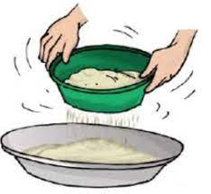 |  | suspension | A mixture between a liquid and particles of a solid when the particles do not dissolve in the liquid.
 |  | sieving | a separating process using a barrier with small to medium-sized holes
 |  | filtering | a process for separating an insoluble solid from a liquid e.g. sand from water
 |  | evaporation | The process of changing a liquid (water) to a gas (water vapour) using heat.
 |  | condense | The process of changing a gas (water vapour) to a liquid (water) by reducing the temperature.

