Key Information | Key Diagrams | Subject Specific Vocabulary
- Your heart will beat about 115,000 times each day. Your heart pumps about 2,000 gallons of blood every day.  - The entire trip around your body only takes blood about 20 seconds in total. Blood is what is used to transport oxygen, waste, nutrients, and more throughout the body.  - The circulatory system includes the heart, blood vessels and blood, and is vital for fighting diseases and maintaining proper temperature.  - Because your heart is crucial to your survival, it’s important to keep it healthy with a well-balanced diet and exercise, and avoiding things that can damage it, like smoking.  - Your heart affects every part of your body. That also means that diet, lifestyle, and your emotional well-being can affect your heart. | The Heart  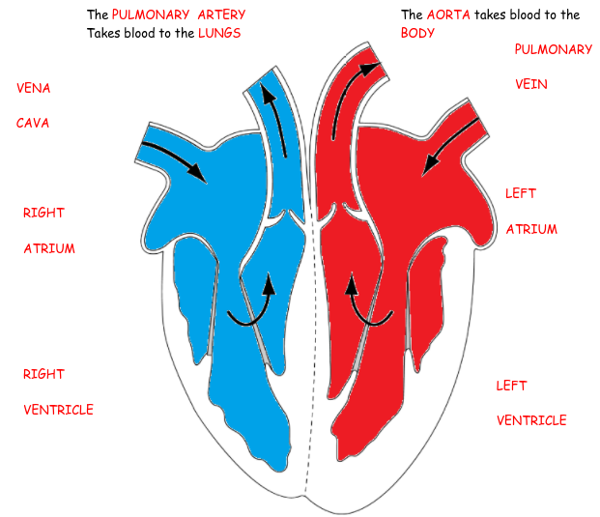  Blood  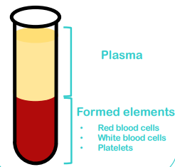  William Harvey (1578-1657)  He was the first person to accurately describe the function of the heart and the circulation of blood around the body. | heart | A strong muscle in the chest protected by the ribs, that pumps blood around the body.
 |  | capillaries | Microscopic blood vessels found in the muscles and lungs.
 |  | artery (arteries) | The vessels that take blood away from the heart.
 |  | veins | The blood vessels that carry blood back to the heart.
 |  | oxygenated blood | Blood that is rich in oxygen.
 |  | de-oxygenated blood | Blood that contains very little oxygen.
 |  | atrium | The upper right and left chambers of the heart.
 |  | ventricles | The lower right and left chambers of the heart.
 |  | drugs | A drug is a chemical that is not food and that affects your body. Some drugs are given to people by doctors to make them healthy.
 |  | pulse | Your heart has to push so much blood through your body that you can feel a little thump in your arteries each time the heart beats.
 |  | blood vessels | Blood vessels are a series of tubes inside your body. They move blood to and from your heart.

