Key Information | Key Scientists | Subject Specific Vocabulary
Electricity travels at the speed of light. That's more than 186,000 miles per second! | Thomas Eddison (1847-1931)  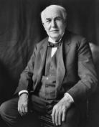  Thomas Alva Edison was a famous American inventor. He is best known for inventing 'domestic' lightbulbs to go in houses, and the electric power system that allows them to work. He came up with over 1000 successful inventions in his lifetime.  Circuit Diagrams  When drawing electrical circuits, you should use the standard symbols to show different components.  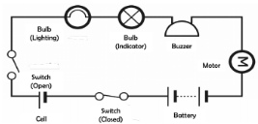  Electrical Symbols  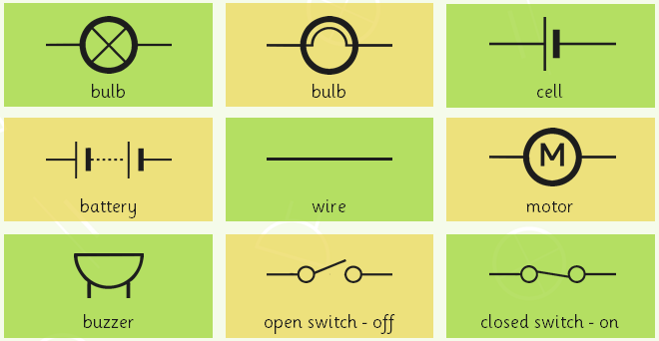 | conductor | Some materials let electricity pass through them easily. These materials are known as electrical conductors.
Coal is the biggest source of energy for producing electricity. Coal is burned in furnaces that boil water and create steam. |  | insulator | Plastic, wood, glass and rubber are good electrical insulators.
Electricity is a type of energy that builds up in one place (static), or flows from one place to another (current electricity). |  | series circuits | A series circuit is one that has more than one resistor, but only one path through which the electricity (electrons) flows.
A popular way of generating electricity is through hydropower. This is a process where electricity is made by water which spins turbines attached to generators. |  | cells | An electrical cell is a device that is used to generate electricity, or one that is used to make chemical reactions possible by applying electricity.
A bolt of lightning can measure up to 3,000,000 volts, and lasts less than one second! |  | volts | Voltage is an electrical potential difference, the difference in electric potential between two places.
Electrical Safety  If electricity is not used safely, it can be highly dangerous. When using electricity, make sure that you:  - Never slide your fingers or objects into a plug socket  - Never use frayed wires - don't pull wires  - Ensure your hands are dry when you are near sockets/electrical equipment  - Don’t overload a plug socket. |  | electrons | Electrical energy is caused by electrons (the particles in atoms) moving about to make a current.
 |  | fuses | These are safety devices. A fuse is a strip of wire that melts and breaks an electric circuit if it goes over a safe level.
 |  | current | The amount of electricity flowing through the circuit (basically a flow of electrons moving in a loop in the circuit). It can be measured using an ammeter and measured in amps.
 |  | generator | A machine that converts energy into electricity.
 |  | components | Key items that make up a circuit e.g. bulb, buzzer, motor, wire

