Key Information | Key Scientists | Subject Specific Vocabulary
- Light travels in straight lines.  - Objects can be labelled opaque, transparent and translucent depending on the amount of light they let through.  - We can see things because light travels from light sources to our eyes or from light sources to objects and then to our eyes.  - Know that light travels in straight lines and therefore shadows have the same shape as the objects that cast them.  - Shadows are formed when light is blocked by an opaque object. | Thomas Young (1773-1829)  Wave theory of light. Double-slit experiment.  Sir David Brewster (1781-1868)  Deduced “Brewster's law” giving the angle of incidence that produces reflected light which is completely polarized; invented the kaleidoscope and the stereoscope, and improved the spectroscope.  Jean-Bernard-Leon Foucault (1819-1868)  Accurately measured the speed of light.  Seeing an object  When light reaches an object, it can be absorbed, or it can pass through the object or it can be reflected. Light can be scattered in all directions. Light colours reflect more light than darker colours. White objects reflect nearly all light. Black reflects very little light.  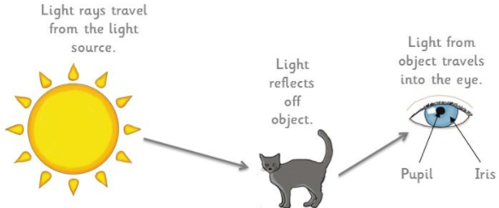 | light source | Light comes from different sources called light sources; our main natural light source is the sun. Other sources include fire, stars and man-made light sources such as light-bulbs and torches.
 |  | transparent | Transparent objects, such as glass, let virtually all light rays pass through them.
 |  | light wave | A light wave is made up of energy in the form of magnetic and electric fields. · Light will travel in a completely straight line until it hits an object that will bend it.
 |  | opaque | Something that is opaque cannot be seen through and does not allow light to pass through it.
 |  | reflect | When light from an object is reflected by a surface, it changes direction. It bounces off the surface at the same angle as it hits it. Smooth, shiny surfaces such as mirrors and polished metals reflect light well.
How Do We See Things?  We see things because:  - they are a light source, sending light into our eyes, or  - light is reflected from a light source, off an object, into our eyes  When light enters our eyes, we see the object. |  | translucent | When light from an object is reflected by a surface, it changes direction. It bounces off the surface at the same angle as it hits it. Smooth, shiny surfaces such as mirrors and polished metals reflect light well.
 |  | refract | Light travels and bounces off surfaces into our eyes. When light travels from air through water, glass or anything that lets light through, it gets bent. This bending is called refraction.
 |  | shadow | Shadows are formed when light from a source is blocked by an opaque object. ​​​​​​​The closer an object is to the source of light the bigger the shadow. Shadows from the sun can be used to tell the time in a sundial.

