 |  |  | Nursery
Themes | Colour & Shape  Families  House & Homes  Autumn  Christmas  Emergency Services |  | Growing/Spring  Vehicles  Easter  Time – Night/Day  Friendship |  | Animals/Pets  Farms  Summer  Other cultures
Key Events | Winnie the Pooh 100th Anniversary  Bonfire Night  Halloween | Christmas  Advent | World Book Day  New Year | Easter  Lent | Farm Visit to School | Roma Gypsy and Traveller Month
Book/ Hook  Talk 4 Writing  Tales Tool Kit | 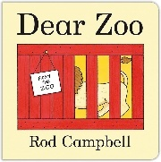  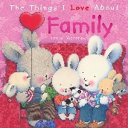 | 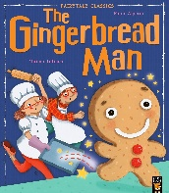  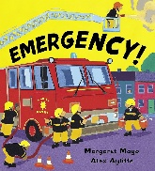  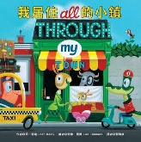  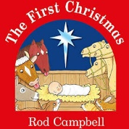 | 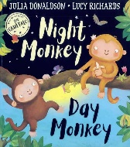  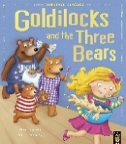  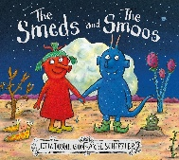 | 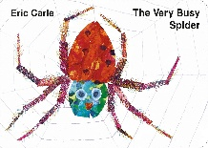  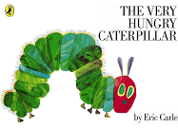  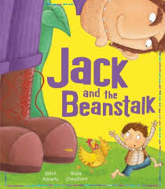 | 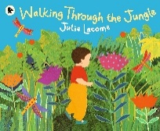  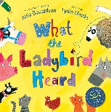  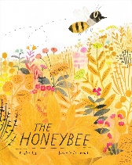 | 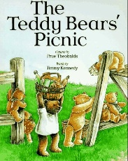
Focus | Mark making opportunities in workshop areas  Use of various media to encourage mark making - chalk, felt pens, crayons, paint, pencils  Encourage children to recognise and begin to ‘write’ their own name  Stories with repeated refrains  Use of props/puppets to encourage children giving focus  Encourage children to predict and retell favourite stories and create their own stories with TTK.
Poetry | Autumn Poems  Nursery Rhymes  Number Rhymes  Rhyming books | Firework Poems  Christmas Poems  Nursery Rhymes  Number Rhymes  Rhyming books | Easter Poems  Nursery Rhymes  Number Rhymes  Rhyming books | Nursery Rhymes  Number Rhymes  Rhyming books | Outdoor Poems  Nursery Rhymes  Number Rhymes  Rhyming books | Nursery Rhymes  Number Rhymes  Rhyming books
Nursery Literacy Texts and Themes Overview 2026-2027

