
St Teresa’s Nursery Medium Term Planning Autumn 1

Area of Learning |  | Week 1 | Week 2 | Week 3 | Week 4 | Week 5 | Week 6
Literacy Focus Texts |  | 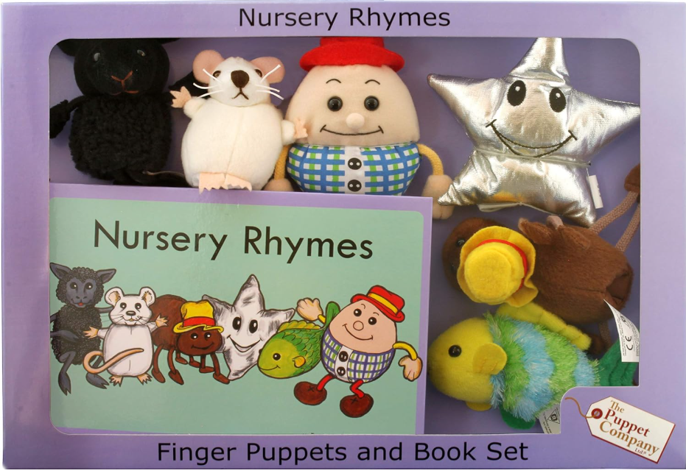 |  | 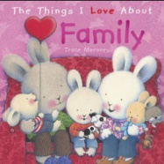 |  | 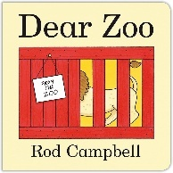
RE |  | Branch 1  Creation & Covenant  Hinge Week | Branch 1  Creation & Covenant  The belief that God made me | Branch 1  Creation & Covenant  Creation is good | Branch 1  Creation & Covenant  Celebrating God as part of his Creation & as part of His family | Branch 1  Creation & Covenant  Celebrating God’s Creation | Branch 1  Creation & Covenant  Looking after myself & our world
Personal, Social  & Emotional Development |  | - Seeks out others to share experiences.  - Expresses own preferences and interests.  - Shows understanding and cooperates with some boundaries and routines.
Communication  & Language |  | Modelling  - Repeat back what the child says correctly  - Add one or two extra words  - Give slight emphasis to any words you want your child to listen to.  - Attention & listening  - Social skills  - Understanding of language  - Use of language
Physical  Development |  | Increase independence in meeting their own care needs (3-4 years)  - Can kick a large ball  - Shows control in holding and using jugs to pour  - Turns pages in a book  - May be showing a preference for a dominant hand  - Clearly communicates their need for potty or toilet.
 |  | Finger gym activities  Threading / pegboard  Daily music & movement | Finger gym activities  Threading / pegboard  Daily music & movement | Finger gym activities  Threading / pegboard  Daily music & movement | Finger gym activities  Threading / pegboard  Daily music & movement | Finger gym activities  Threading / pegboard  Daily music & movement | Finger gym activities  Threading / pegboard  Daily music & movement
Pre-Phonics |  | Aspect 1 –  Environmental Sounds  Tuning into sounds  Sound lotto  Look, listen, note –  Recall sounds they have heard  Discriminate between the sounds  Describe the sounds they hear | Aspect 2 –  Instrumental Sounds  Tuning into sounds  Which instrument?  Look, listen, note –  Identify and name the instruments being played  Listen & respond as the instrument is being played | Aspect 3 –  Body Percussion  Tuning into sounds  Action songs  Look, listen, note –  Produce contrasts in rhythm, speed and loudness  Join in with words and actions to familiar songs  Articulate words clearly  Keep in time with the beat  Copy the sounds and actions  Make up patterns of sounds | Aspect 4 –  Rhythm & Rhyme  Tuning into sounds  Rhyming books  Sharing a Shell  Look, listen, note –  Understand the pattern of syllables in words  Sing or chant the rhyming string along with the adult  Recognise that the words rhyme  Join in with simple or complex rhythms  Copy the rhythm  Keep to the beat | Aspect 5 –  Alliteration  Tuning into sounds  I spy games  /m/ and /a/ initial sounds  Look, listen, note –  Identify initial sounds in words  Reproduce the initial sounds clearly and recognisably  Make up their own alliterative phrases | Aspect 6 –  Voice Sounds  Tuning into sounds  Mouth movement  Look, listen, note –  Distinguish between the differences in vocal sounds
Maths |  | Routines & Noticing  Number rhymes – 5 Little Men; Currant Buns; Little Ducks; Little Monkeys support using 5 frames  Number Sense  Noticing – what can you see?  Join in with number rhymes, action songs and movement games  Subitising 1,2 & 3  Play games 1, not 1. 2, not 2. 3, not 3.  Able to hold up 1,2,3, fingers  Sorting and classifying  Matching things that go together  Exact matching – Find my match?  Sorting by a single attribute - What’s my rule?  Spatial relationships  Understand where things are in the class  Follow instructions e.g. Put it under…  Time  Starting to understand about nursery routine  Use vocab- morning, afternoon, lunchtime, home time  Shape/pattern:  Arranging construction, shapes and loose parts to make patterns, towers and pictures  Properties – comparing/sorting/matching (noticing)  2D Shapes and their properties  Measures - a direct comparison  Language of tall/short  Short/long  Heavy/light  Day/night  Full/empty
Understanding the World |  | Talk about myself  My Family  My Body |  | My Home  Who I live with |  | Talk about colours  Colour recognition  Autumn Weather  Changing Seasons  Halloween
Expressive Arts  & Design |  | 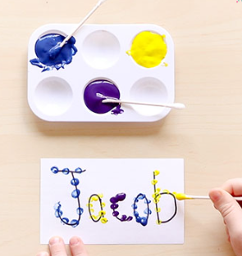Fine Motor & Name Recognition | 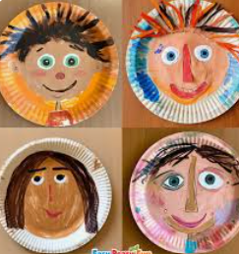Self-portraits | 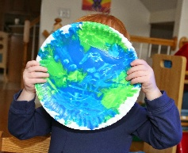Our World – RE Focus |   Crosses | 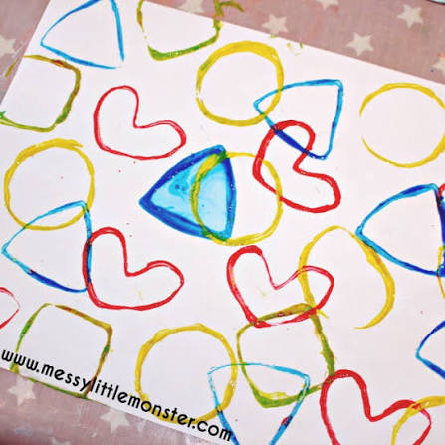  2D Shape Printing | 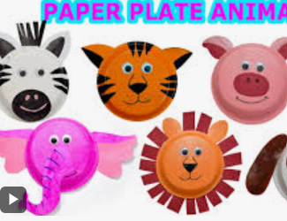  Animals – Literacy Focus
SEND/  Interventions |  | Disco dough  C&L – Talk Boost  SALT | Disco dough  C&L – Talk Boost  SALT | Disco dough  C&L – Talk Boost  SALT | Disco dough  C&L – Talk Boost  SALT | Disco dough  C&L – Talk Boost  SALT | Disco dough  C&L – Talk Boost  SALT

