
St Teresa’s Nursery Medium Term Planning Autumn 2
Area of Learning | Week 1 | Week 2 | Week 3 | Week 4 | Week 5 | Week 6 | Week 7
Literacy | 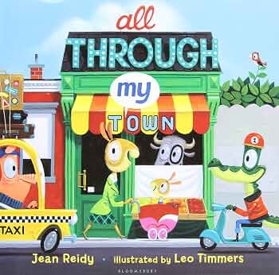 |  | 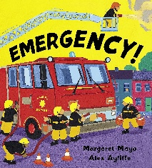 |  | 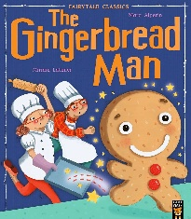 |  | 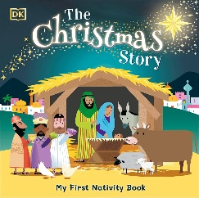
RE | Branch 2  Prophecy & Promise  Hinge Week | Branch 2  Prophecy & Promise  Mary is going to have a baby, Jesus | Branch 2  Prophecy & Promise  The Nativity | Branch 2  Prophecy & Promise  Hinge Week | Branch 2  Prophecy & Promise  The Tradition of the Crib | Branch 2  Prophecy & Promise  Advent Celebrations | Branch 2  Prophecy & Promise  Advent, a time to prepare
Personal, Social  & Emotional Development | - Seeks out others to share experiences and may choose to play with a familiar friend.  - Talk about their feelings using words like ‘happy’, ‘sad’, ‘angry’ or ‘worried’.  - Remember rules without needing an adult to remind them.  - Learn to use the toilet with help, and then independently.
Communication  & Language | Modelling  - Repeat back what the child says correctly  - Add one or two extra words  - Understand simple questions about ‘who’, ‘what’ and ‘where’ (allow thinking/processing time)  - Give slight emphasis to any words you want your child to listen to.  - Attention & listening  - Social skills  - understanding of language  - use of language
Physical  Development | - Can catch a large ball  - Use one handed tools and equipment eg. making snips in paper with scissors  - Turns pages in a book  - May be showing a preference for a dominant hand  - Clearly communicates their need for potty or toilet.  - Become increasingly independent as they get dressed and undressed.
Physical  Development | Finger gym activities  Threading / pegboard  Daily music & movement | Finger gym activities  Threading / pegboard  Daily music & movement | Finger gym activities  Threading / pegboard  Daily music & movement | Finger gym activities  Threading / pegboard  Daily music & movement | Finger gym activities  Threading / pegboard  Daily music & movement | Finger gym activities  Threading / pegboard  Daily music & movement | Finger gym activities  Threading / pegboard  Daily music & movement
Pre-Phonics | Stage 1 - Speech detection  Drum Outdoors  Purpose:  • To recognise that the same object can make different sounds.  • To explore how to make different sounds. | Stage 2 – Syllable awareness  Syllable Clapping  Purpose:  • To develop syllable awareness | Stage 3 – Onset & Rime  Onset Posting  Purpose:  • To identify a target onset when provided orally by the adult. | Stage 4 - Rhyme detection  Rhyming Pairs  Purpose:  • To identify words that rhyme. | Stage 5 – Initial Sounds  Initial Bubbles Game  Purpose:  • To recognise the initial sound of a c-v-c word. | Stage 6 – Rhyme Production  Name Rhymes  Purpose:  • To play with rhyme. | Stage 1 - Speech detection  Action songs  Purpose:  • To detect the difference between speech sounds and other environmental sounds.
Maths | Routines & Noticing  Number Sense  Noticing – what can you see?  Join in with number rhymes, action songs and movement games  Subitising 1,2 & 3  Able to hold up 1,2,3, fingers  Spatial awareness  Respond to some spatial and positional language  Understands position through words alone  Responds to and uses language of position and direction  Begins to remember their way around familiar environments  Describe a familiar route  Discuss routes and locations using words like in front of and behind.  Time  Starting to understand about nursery routine  Use vocab- morning, afternoon, lunchtime, home time  Use special times to understand the concept of time – Bonfire night, Christmas, birthdays etc  Shape/pattern:  Arranging construction, shapes and loose parts to make patterns, towers and pictures  Properties – comparing/sorting/matching (noticing)  Measures - a direct comparison  Recognising attributes - what kind of bigger is it?  Comparing amounts of continuous quantities – how can we compare?  Show awareness of comparison in estimating and predicting – eg. making a bed for teddy using blocks
Understanding the World | Changing Seasons  Outdoor Explorers – Natural Resources  My Town – Darlington |  | Occupations  Emergency Services |  | Forces  Stretching  Bending  Floating/Sinking  Celebrations  New Year/Christmas
Expressive Arts  & Design | 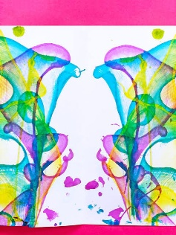  String Painting | Class Artwork – Jesus Name Art | 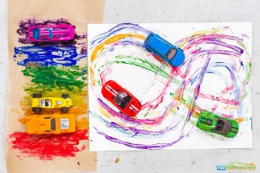  Driving cars in paint | 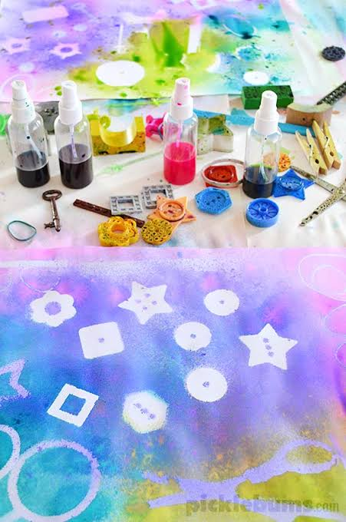  Spray bottles & Stencils |  | 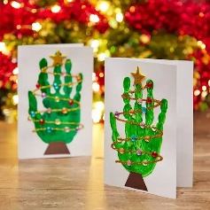 | 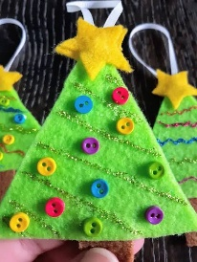
SEND/  Interventions | Disco dough  C&L – Talk Boost  SALT | Disco dough  C&L – Talk Boost  SALT | Disco dough  C&L – Talk Boost  SALT | Disco dough  C&L – Talk Boost  SALT | Disco dough  C&L – Talk Boost  SALT | Disco dough  C&L – Talk Boost  SALT | Disco dough  C&L – Talk Boost  SALT

