SEND Information Report
Approved on:
July 2023
Next review:
June-July 2024
St. Teresa’s Catholic Primary School

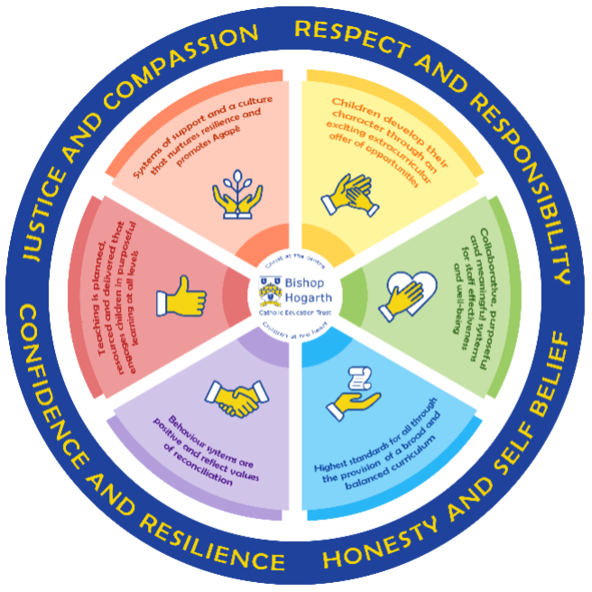

As part of the family of Bishop Hogarth Catholic Education Trust, our school has at its core, the virtues, and values of:
Respect for others and themselves, recognising that we are all created in the image of God and therefore must be compassionate towards others, especially the vulnerable. ​
Confidence in their own abilities, knowing that their talents are gifts from God and resilience to persevere when things become difficult. ​
Honesty in regard to the world around them and themselves and the ability to take responsibility for the times we may fall short of the mark. ​
Gratitude for all the amazing gifts from God and willingness to share their gifts both personal and material. ​

As an inclusive school, all teachers are teachers of pupils with Special Educational Needs & Disabilities. We deliver a curriculum and create an environment that meets the needs of every pupil within our school. We ensure that every pupil with Special Educational Needs and / or disabilities makes the best progress possible. We foster and promote effective working partnerships with parents / carers, pupils, and outside agencies. We consider the ‘whole’ child and strive to ensure that all our SEND pupils are prepared for adulthood.​

Our school’s approach to supporting pupils with SEND

At St. Teresa’s, we strive to offer every child a high-quality educational experience. Careful observation and monitoring from an early age allows us to identify children who appear to have difficulties with one or more of the four areas of need outlined in the SEND Code of Practice. These include:
• Cognition and Learning – moderate/specific learning difficulties e.g. Dyslexia, Dyspraxia, Attention Deficit Hyperactivity Disorder (ADHD).
• Communication and Interaction – e.g. Autistic Spectrum Disorder (ASD), speech and language difficulties.
• Social, Emotional and Mental Health – e.g. attachment/difficulties forming relationships.
• Sensory and Physical development – e.g. vision/hearing impairment, Epilepsy etc.
This means that appropriate support can be planned and implemented at the earliest opportunity in order to ensure every child is catered for and reaches their full potential.
The aims of our approach to supporting children with special educational needs and disabilities at St. Teresa’s are:
• To make reasonable adjustments for children with SEND by taking action to increase access to the curriculum, the environment and to information for all.
• To ensure that children and young people with SEND engage in the activities of the school alongside pupils who do not have SEND.
• To reduce barriers to progress by embedding the principles in the National Curriculum Inclusion statement: https://www.gov.uk/government/collections/national-curriculum
• To use our best endeavours to secure special educational provision for pupils for whom this is required, that is “additional to and different from” that provided within the differentiated curriculum, to better respond to the four broad areas of need.
• To request, monitor and respond to parent/carers’ and pupils’ views in order to evidence high levels of confidence and partnership.
• To ensure a high level of staff expertise to meet pupil need, through well-targeted continuing professional development.
• To support pupils with medical conditions to achieve full inclusion in all school activities by ensuring consultation with health and social care professionals in order to meet the medical needs of pupils.
• To work in cooperative and productive partnership with the Local Authority and other outside agencies, to ensure there is a multi-professional approach to meeting the needs of all vulnerable learners.

The first step in providing education for children, including those with special educational needs and/or disabilities is high-quality teaching that is differentiated to meet the needs of all learners. Class teachers are responsible for ensuring all of the children within their class are supported and challenged appropriately .The quality of classroom teaching provided to pupils with SEND is monitored through a number of processes that include: classroom observation by the senior leadership team, the SENCo., external verifiers; ongoing assessment of progress made by pupils with SEND; work sampling and scrutiny of planning to ensure effective matching of work to pupil need; teacher meetings with the SENCo. to provide advice and guidance on meeting the needs of pupils with SEND; pupil and parent feedback on the quality and effectiveness of interventions provided; attendance and behaviour records.
All pupils have individual national curriculum targets set in line with national outcomes to ensure ambition. Parents are informed of these via the reporting system and also at twice-yearly parents’ evenings. Parents of children with SEND are invited into school on a termly basis (three times a year). Pupils’ attainment is tracked using a whole school tracking system and those failing to make expected levels of progress are identified quickly.
These pupils are then discussed in termly progress meetings that are undertaken between the class teacher and a member of the senior leadership team (often the SENCo.). Additional action to increase the rate of progress will be then identified and recorded. This will include a review of the impact of the teaching/intervention being provided to the child, and if required, provision to the teacher of additional strategies to further support the success of the pupil. Where it is decided - during this early discussion - that special educational provision is required, parents will be informed that the school considers their child may require SEND support and their partnership will be sought in order to improve outcomes.

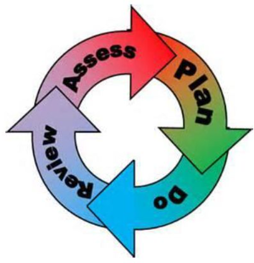
How will the school staff support my child?
The graduated response-Identifying, planning for and supporting pupils with SEND
Where a pupil is identified as having a special educational need, School will follow a graduated approach which takes the form of cycles of ‘Assess, Plan, Do, Review’. ​
• Assess a child’s special educational need. ​
• Plan the provision to meet your child’s aspirations and agreed outcomes. ​
• Do put the provision in place to meet those outcomes. ​
• Review the support and progress.

How does the school know if children need extra help and what do I do if I think my child has special educational needs?

- Assess

Teacher assessment plays a major role in identifying gaps in knowledge and understanding. With the support of the senior leadership team, classroom teachers conduct regular progress assessments for all pupils with the aim of identifying those who are making less than expected progress. An emphasis is placed on early identification. Therefore, the school SENCo. and Early Years professionals liaise regularly to discuss any concerns that may arise following early observations of children. Additional/alternative tools may be required when children are not making expected progress. This can be characterised by progress which: is significantly slower than that of their peers starting from the same baseline; fails to match or better the child’s previous rate of progress; fails to close the attainment gap between the child and their peers: or, widens the attainment gap. Other ways school may learn that a pupil needs additional help include: concerns being raised by parents/carers, external agencies (if already involved), the pupil’s previous provision or the pupil themselves.
If parents have concerns relating to their child’s learning needs, they should initially discuss these with their child’s teacher. This may result in a referral to the school SENCo. (Mrs Gate). Parents may also contact the SENCo. or the Headteacher (Mrs Bruton) directly if they feel this is more appropriate (contact details provided at the bottom of this document). All parents will be listened to. Their views and their aspirations for their child will be central to the support that is provided by the school. Parents are always informed if school staff consider that their child has an additional need and parents and children (as appropriate - depending upon age and capability) are involved in the planning to meet this need(s).
School often recommend initially that eyesight and hearing are checked to discount these aspects as possible underlying causes of learning issues. Progress in areas other than attainment is also considered. For example, where a child needs to make additional progress with social or emotional needs in order to be fully integrated into school life. If behaviour is causing concern, it is always considered whether there are any underlying difficulties; if there are none, the class teacher will speak to parents/carers about anything that might have happened at home. The class teacher/SENCo. will gather information about incidents occurring, at what time of day, during which lessons and behaviour checklists may also be used to analyse and consider any patterns of behaviour. Observations will be carried out in class/on the playground considering the involvement of others and environmental factors. An intervention will then be devised taking into account all of the information gathered.

- Plan

Following appropriate assessment, if it is evident that support that is “additional to and different from” what would usually be provided is required, then the views of all involved including the parents and the pupil will be obtained. Evidence-based interventions (following advice from specialist services if sought) will then be planned.

SEND support will be recorded on a ‘School Support Plan’ that will identify a clear set of expected outcomes. This will include relevant academic and developmental targets. School refer to these as SMART targets as all targets set should be: Specific (well-defined clear and unambiguous); Measurable (with particular criteria that measures the child’s progress towards the accomplishment of a goal); Achievable (attainable and not impossible to achieve); Relevant (appropriate to the child’s life purposes); Time-bound (with a clearly defined timeline to create a sense of urgency). These targets will also take into account parents’ aspirations for their child. Parents and the pupil will be consulted on the action they can take to support the attainment of these desired outcomes.

- Do

Our teachers are skilled at adapting teaching and learning to meet the diverse needs in each class. ​
Daily planning considers individual children’s needs and requirements and is annotated and adapted according to need. Explicit reference is made in the teacher’s planning to the needs of those children identified with SEND. ​

Adaptive teaching is approached in a range of ways to support access to the curriculum and ensure that all children can experience success and challenge in their learning. ​
Grouping arrangements consider the different skills and abilities of each child. This ensures that learning is maximised. ​

Additional adults support groups and individual children with the long-term goal of developing independent learning skills. The class teacher monitors this support to avoid students becoming over reliant on this. ​

We fully encourage parental support and offer opportunities for individual meetings with parents/carers to provide clarity and recommendations on how they can support their child at home.

- Review

Progress towards personalised outcomes will be tracked and reviewed termly with the parents and the pupil. If progress rates are judged to be inadequate despite the delivery of high-quality interventions, advice will be sought from external agencies regarding strategies to best meet the specific needs of a pupil. This will only be undertaken after parental permission has been obtained and may include referral to: - Local Authority Support Services; - Specialists in other schools e.g. teaching schools, special schools; - Social Services; - Health partners such as Speech and Language, Occupational Therapy, the School Nurse and Child & Adolescent Mental Health Service. For a very small percentage of pupils, whose needs are significant and complex and the SEND Support required to meet their needs cannot reasonably be provided from within the school’s own resources, a request will be made to the local authority to conduct an assessment of education, health and care needs. This may result in an Education, Health and Care (EHC) plan being provided.

St. Teresa’s recognise the value in involving pupils (if appropriate) in decisions made regarding the planning for provision to better suit their needs. We therefore also use pupil centred profiles (passports). These are completed by the pupils themselves (with support if required) and identify their abilities and strengths, their personal aims and the action they require to be taken by the school to reduce barriers to learning and social success. Each term, this information will be reviewed and the pupil’s views listened to.

How will the curriculum at our school be matched to my child’s needs?
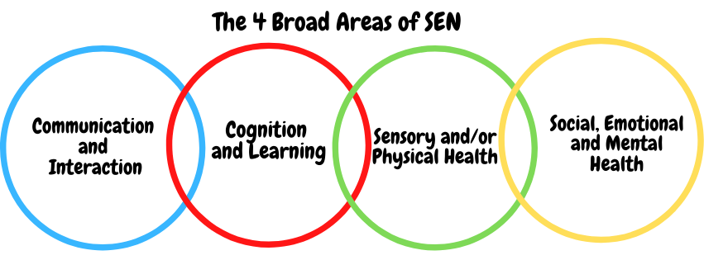SEN needs are classified under four broad areas of need. Below are the strategies, in class support and interventions that school may put in place to support your child.
Communication and Interaction
Strategies to support children with these needs include:
- Identifying whether a child has a delay in speech and language through observations in the classroom and playground, discussions with parents and the SENCo. This will involve pinpointing specific areas of difficulty such as: problems producing sounds correctly, problems understanding/using language or problems using and understanding non-verbal communication. This may lead to a referral to the Speech and Language Therapy Service. Children accepted into the service are often provided with specialist therapy sessions which are usually delivered in school. Alternatively, staff may be given recommendations of activities to carry out with the child. These tend to be delivered by an experienced teaching assistant who knows the child well.

- Identifying other conditions or diagnoses that would be beneficial to explore including: Developmental Language Disorder, Auditory Processing Disorder or Autism Specrtum Disorder. Appropriate referrals (perhaps to the Neurodevelopmental Pathway or Educational Psychology Service) would then be carried out with recommendations followed.
- The SENCo working in close partnership with pupils, parents, teachers and language/communication experts to ensure pupils with communication and interaction needs reach their potential.

- Day-to-day classroom support including: access to visuals/concrete manipulatives, clear class routines (with enhanced explanations around any unexpected changes), regular check-ins to ensure pupils have understood, positive reinforcement and rewards, additional time for processing, a clear system for asking for help (e.g. cards/non-verbal gestures etc.), modelling/repetition, reduction in language load, multi-sensory approaches where possible and pre-post teaching opportunities.

Cognition and Learning

Strategies to support children with these needs include:
- Understanding that difficulties with cognition and learning covers a wide range of needs and pinpointing the specific area of difficulty that a child has. The SENCo will work with teaching staff and external professionals to identify whether a child has a: moderate learning difficulty (MLD), severe learning difficulty (SLD) or a profound and multiple learning disabilities (PMLD). Specific learning difficulties (SpLDs) affect one or more specific aspects of learning. This encompasses a range of conditions such as dyslexia, dyscalculia and dyspraxia.
- Employing a range of day-to-day strategies to help support children who may have the above. The first of these is high quality teaching for all. To compliment this, additional steps/measures or adaptations may also be put in place. For example, to increase access to text, targeted differentiation (e.g. desk copies of information, work buddies, accessible text, ICT e.g. read aloud software, different recording strategies, additional time etc.) will be put in place for those who require it. In class, adult or peer support aimed at increasing skills in specific area of weakness (learning behaviours, organisation, etc.) is commonly used in our classrooms. Out of class support (1:1 focused intervention or small group tuition to enable catch up) is another regular tool. School also aim to provide specific support, advice and guidance to parents and families to improve pupil’s readiness for learning. Some pupils may also be given access to technology or specialist resources/equipment (use of ipads, sloping boards, electronic versions of text etc).

- Children who display traits of dyslexia (with or without a diagnosis) have access to specialist intervention programmes such as ‘Literacy Gold’ which focuses mainly on the acquisition of key reading skills. Other support for children experiencing difficulties commonly associated with dyslexia include: access to coloured overlays, 1:1 pupil conferencing and access to assistive technology such as spelling dictionaries and dictation apps.

Sensory/Physical

Strategies to support pupils with these needs include:

- Providing pupils with medical needs with a detailed Individual Health and Care Plan, compiled in partnership with the school nurse, other relevant health professionals, parents and, if appropriate, the pupil themselves. Staff who administer and supervise medications have completed dedicated training for this. Medicine administration procedures adhere to the local authority policy and Department of Education (DfE) guidelines included within Supporting pupils at school with medical conditions (DfE) 2014 and identified in the School Medicine Administration Policy.

- Ensuring that impairments (e.g. hearing/visual) do not prevent or hinder pupils from using school facilities and accessing the learning they are entitled to. This may involve: seeking support from specialist services, using a radio aid, ensuring seating arrangements have been carefully considered, communicating regularly with parents/carers.

- Providing children who experience sensory difficulties with access to appropriate resources (e.g. a sensory box, fidget toy etc.). Staff may also deliver a sensory diet for children who have been identified as needing regular sensory input. Children who experience sensory overload or who are sensitive to noise are provided with ear-defenders and have access to quiet/calm spaces when needed.

Social, Emotional and Mental Health

Strategies to support children with these needs include:
- Recognising that pupils who experience social and emotional difficulties may present with behaviours that manifest themselves in many ways, including becoming withdrawn or isolated, or displaying challenging, disruptive and disturbing behaviour. School acknowledge that these behaviours may reflect underlying mental health difficulties such as anxiety or depression. The school will ensure that provisions and allowances are made for the ways in which these mental health difficulties can influence the behaviour of pupils and will seek to manage the effect of any disruptive behaviour so that it doesn’t adversely affect other pupils.
- Delivering a whole-school Personal, Social, Health and Economic (PHSE) curriculum that aims to provide pupils with the knowledge, understanding and skills needed to enhance their emotional and social well-being.

- 1:1 or small group evidence-led interventions to support pupil’s well-being that are delivered to targeted pupils. These are ran by experienced and highly-trained members of staff (e.g. our Parent Support Advisor (PSA), Mrs Elliott and Emotional Literacy Support Assistants (ELSAs, Mrs Mowbray and Mrs Hitchen) and aim to support improved interaction skills, emotional resilience and wellbeing. Mindfulness sessions are also delivered regularly by a highly-experienced in school practitioner. Dedicated ‘nurture time’ is provided for those children who benefit from regular emotional ‘check ins’.

- Arrangements with outside agencies including Counselling services (ABC Therapy) and Alliance who specialise in supporting children who experience difficulties around mental health.
• Providing pupils who find outside class times difficult with alternative small group opportunities within school. Action is taken to develop their social interaction skills in a number of ways. These include: encouragement to join groups/clubs catered to their interests, and the opportunity to take part in dedicated programmes targeting the development of key social skills.
- Partnership working with other settings (shared resources e.g. Parent Liaison Worker; shared expertise: support from local special school on action to improve inclusion: shared alternative environments etc.).
- Liaison and referrals to the school nurse and wider health professional support (responding to mental and physical health issues, speech, language and communication needs, motor control and mobility needs). Access to support from in-school sources e.g. learning mentors (peer or adult) or from charities (e.g. Alice House Hospice – Bereavement Counselling) and community sources.

What training is provided for staff supporting children with SEND?
Our team of teachers and teaching assistants have extensive experience and training in planning and delivering successful lessons and intervention programmes. Staff take part in continuous professional development across the year on the differing needs of the pupils in our school. This can include training from specialist agencies (e.g. Educational Psychology, Speech and Language, Occupational Therapy, specialists in children’s mental health) as well as from our SENCo. or other staff with relevant expertise.

How do we support transition in our school?

Transition within classes/key stages: ​
A number of strategies are in place to enable effective transition for pupils, especially for those with SEND. These include: On entry:
• Parent/carers are invited to a meeting at the school or a home visit is arranged and parents/carers are provided with a range of information to support them in enabling their child to settle into the school routine.
• The SENCo. meets with all new parents of pupils who are known to have SEND to allow concerns to be raised and solutions to any perceived challenges to be discussed prior to entry.
• If pupils are transferring from another setting, the previous school records will be requested immediately and a meeting set up with parents to identify and reduce any concerns.

Transition to Secondary settings: ​
In preparing children to transition from primary to secondary school:
• The transition programme in place for pupils provides a number of opportunities for pupils and parents to meet staff in the new school. These opportunities are further enhanced for pupils with SEND (on a needs basis) and are discussed in detail with parents accordingly.
• Person centred planning meetings are held for all pupils on the SEND register. This involves input from the child themselves, their parents, class teacher, other key workers, the SENCo. (from the primary and secondary school) and any other relevant members of staff from the secondary school. These meetings feed into a comprehensive plan for a successful, smooth transition.

Where can I get further information about services for my child?

The Local Offer
The full range of local support available for children/young people with SEND and their families within and outside of school can be found on the Hartlepool LA local offer webpage. Click on the link below to access this.
Hartlepool Now :: Local Offer

What key school documents refer to support and provision for pupils with SEND?

- SEND Policy​
- Admissions Policy​
- Supporting Pupils with Medical Needs Policy​
- Accessibility Plan​

Accessibility​
Pupils with a disability will be provided with reasonable adjustments (such as auxiliary aids and support from external services) to overcome any disadvantage experienced in school and increase their access to the curriculum. More information on how our school caters for children with specific disabilities can be found in our Accessibility Plan.

Activities Outside of School​
Children with special educational needs and/or disabilities are given full accessibility to activities taking place outside of school. This may include: sporting events, ‘hands on’/practical activities/courses, vocational opportunities, residential trips etc. To ensure children with additional needs are able to participate fully, careful consideration is given to staffing and risk assessments are completed in detail.

What to do if you have a complaint, a compliment, or a query.

The Information, Advice and Support Agency Network offers independent advice and support to parents and carers of all children and young people with SEND and will direct visitors to their nearest IAS service:

http://www.iassnetwork.org.uk/

For parents who are unhappy with the Local Authority or school responses to their child’s SEND, parents may seek mediation from the regional mediation services. Information on this free service is located here:

http://preview.tinyurl.com/qx5a8vq

Parents and carers can also appeal to the Government’s SEND tribunal if you disagree with the Local Authorities decisions about your child’s special educational needs. You can also appeal to the tribunal if you feel the school or council has discriminated against your disabled child. Information on this process is available here:

http://preview.tinyurl.com/ovg4so3

The school details and relevant contacts
Mrs Gate (SENCo) can be contacted via phone on: 01429 273936 or via email at: senco@stteresashartlepool.bhcet.org.uk

Mrs Elliott (PSA) can be contacted via phone on: 01429 273936 or via email at: psa@stteresashartlepool.bhcet.org.uk

Mrs Bruton (Head Teacher) can be contacted via phone on: 01429 373936 or via email at: admin@stteresashartlepool.bhcet.org.uk

​
Name of school SEND governor.
Jane Jennings is our school’s SEND governor.

