English
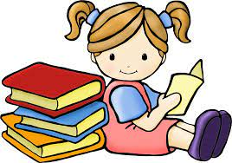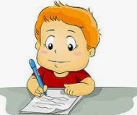
In English, this half term we will be focusing on the theme “Imaginary Worlds,” The children will be developing their writing based upon stories set within a magical world which we will read together to create pieces of writing such as setting descriptions, character descriptions, a story, poetry and reports. The children will be producing both fiction and non – fiction pieces of writing. The children will also be looking at basic skills within writing such as capital letters, punctuation and sentence construction building upon skills we looked at in Autumn 1. The children will also be continuing to use editing and drafting skills. In Reading, children will be using their VIPERS knowledge to answer a range of questions with a focus on retrieving and explaining information within a text. We will also continue to work on fluency and vocabulary. building. as a class.
Maths-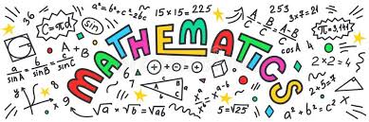 As mathematicians, children in Year 3 will be building their multiplication and division knowledge looking at the 3, 4 and 8 times tables. Children will then be using this times tables knowledge to look at written methods for multiplication (2 digit by 1 digit).
Building on Year 3, children in Year 4 will also be looking at developing their multiplication knowledge of the 6,7,9,11 and 12 times tables. Children will also be looking at multiplying and dividing by 10 and 100.
Year 4 will also be looking at length and perimeter converting mm, cm, m and kms as well as measuring rectilinear shapes.

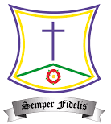
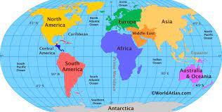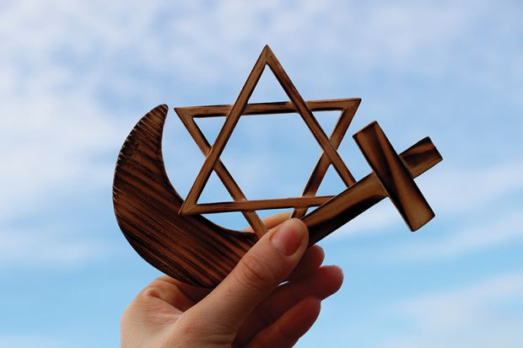
St. Teresa’s RC Primary School
Spring1 Curriculum 2022
LKS2 – Autumn 2 2022 - Curriculum
Spring1 Curriculum 2022
Geography – In geography, we will be looking at Where in the World – UK and Europe. We will be looking at map skills, mountains and rivers, European countries, time zones and holidays in Europe.
.

Science:
In Science, children will be looking at Animals including Humans. We will be looking at nutrition and vitamins, different types of skeletons and how muscles and joints work. We will be comparing human skeletons and animal skeletons to see how and why they are different.

D&T - In D&T, the children will be designing and creating Pneumatic Toys. Children will be learning to think about their designs, cutting and measuring as well as evaluating their final product. Children will also be working both independently and as a team.

PE – In PE, children will be focusing on invasion games (Football) in Year3 and Street Dance in Year 4 as well as continuing with their weekly
swimming lessons. 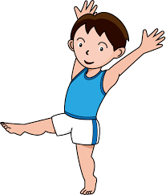

Homework
Children are expected to read at least twice a week at home as well as practise their weekly spellings and maths homework.

Music – In music, children will be developing their singing technique as well as beginning to recognise notation. We will also have a genre of the week to listen and discuss.

RE
This half term, children will be looking at the Sacramental programme for Reconciliation. Following this, the children will be looking at the Advent topic: Gift focusing on how Jesus was a gift sent to us by God.


Computing – This half term, the children will be looking at Creating media with a focus on Audio programming. We will be looking at recording audio and analysing what makes a good podcast.



