English
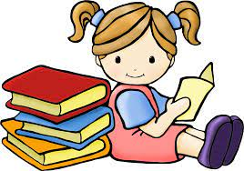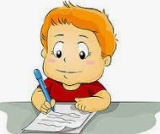
In English, this half term Mrs Leonard’s and Mrs Cook’s class will be reading The Iron Man and Miss Eglintine’s class will be reading The Whale. The children will be developing their writing based upon these stories. They will create pieces of writing such as a setting description, a character description, a story and poetry. The children will also be building upon skills we looked at in Autumn 1 and 2. This will include capital letters, punctuation and sentence construction The children will be continuing to use editing and drafting skills as well as peer assessment. In Reading, the children will access a variety of texts which will allow them to develop their skills and knowledge. They will analyse words and phrases, make predictions, answer a wide variety of comprehension questions, give explanations using the text and make inferences.

Maths-
As Mathematicians, the children in Year 3 will continue to build upon their multiplication and division knowledge by practising the 2, 5 and 10 times tables and learning the 3, 4 and 8 times tables. The children will then be using their times tables knowledge and to complete calculations using the formal written methods for multiplication and division. They will also solve related calculations and problem solve. Building on Year 3, children in Year 4 will also be looking at developing their multiplication knowledge of the 6,7,9,11 and 12 times tables as well as calculating area.

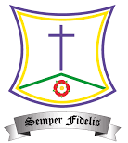
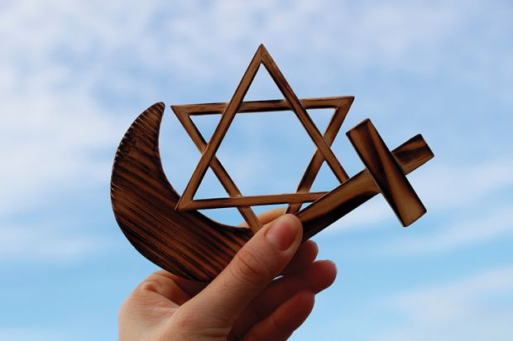
St. Teresa’s RC Primary School
Spring 2 Curriculum 2023

LKS2
Year 3 and 4
RE:
In RE, the children will focus on journeys. This will include: a journey through the liturgical year, the feasts of Our Lady and the life journey of prayer. The children will also be introduced to sacramental preparation.

Geography:
In geography, the children will be looking at Angry Earthquakes & Volcanoes. We will study the structure, formation, location and effects of earthquakes and volcanoes.

Science:

In Science, our new topic is Sound. The children will learn about vibrations, sounds waves, volume and pitch. They will learn how we hear, how the ear works, and measure sounds across distance.

Computing:
In computing, the children will be editing photographs. This will include changing the composition of and retouching images.

D&T: In D&T, the children will be adapting a recipe. They will work in groups to bake biscuits, adapt an existing biscuit recipe and consider the cost of ingredients and other expenses against a set budget.

PE: In PE, children will be focusing on gymnastics as well as continuing with their weekly swimming lessons. 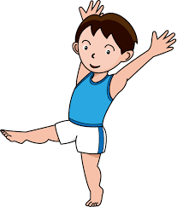

PHSE:
In PHSE, the children will be learning about being kind and staying safe, including how to stay safe online.

Music: In music, the children will be focusing on South African music and instruments. They will identify key features of staff notation and compose rhythmic patterns for a gumboot dance.




