**Maths-**

As Mathematicians, Year 3 and 4 children will be moving onto length and perimeter. We will be using mm, cm, m and km. the children are expected to convert between these units of measurement, read scales and calculate perimeter. Year 4 will also be also be finding the area of shapes by counting squares and using multiplication methods.

**English**

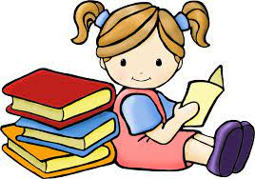 

In English, this half term Mrs Leonard’s and Mrs Cook’s class will be reading Fox and Mrs Ward’s class will be reading Leaf. The children will be developing their writing based upon these stories. They will create pieces of writing such as a setting description, a character description, a story and poetry. The children will also be building upon skills we looked at in the Autumn term and Spring 1. This will include capital letters, punctuation and sentence construction The children will be continuing to use editing and drafting skills as well as peer assessment. In Reading, Mrs Leonard and Mrs Cook’s class will look at a variety of stories and poetry. Mrs Ward’s class will look at a range of texts about the Vikings. They will analyse words and phrases, make predictions, answer a wide variety of comprehension questions, give explanations using the text and make inferences.

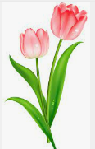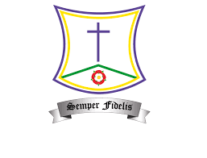

**French:** In French, children will be learning how to describe what they look like. They will move onto describing other characters and playing games to “guess who!”

**Music:** In music, the children will be focusing on ballads. The will learn to recognise a ballad, how to identify their features and how to convey different emotions when performing them.

**Computing:**

In computing, the children will use a range of resources to learn how to programme.



**Art:** In Art, we will be enhancing our drawing skills by developing an awareness of proportion and pattern and combining medias for effect when making prints.

**Science:**

In Science, our new topic is Plants. We will be studying the life cycle and the function of plants and flowers.

**History:**

In History, we will be learning about the Ancient Greeks. We will be placing key events in Greek history on a timeline, learning about Greek gods and goddesses, the Olympics and how Ancient Greece influences us even today.

**PE:** In PE, children will be focusing on basketball as well as continuing with their weekly swimming lessons. 

**RE:**

In RE, the children will learn about Lent. This will include: a journey through the liturgical year, the feasts of Our Lady and the life journey of prayer. The children will also be introduced to sacramental preparation.

St. Teresa’s RC Primary School

Spring 2 Curriculum 2023

LKS2

Year 3 and 4

**PHSE:**

In PHSE, the children will be learning about being kind and staying safe, including how to stay safe online.

