We all hear about the importance of adults reading to children but why is this so important?

***Did you know?***

**Children who have shared lots of stories, enjoy reading and have better language skills when they get older.**

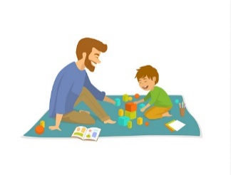

***Did you know?***

**You are the most important person in developing your child’s language. When you respond to your child’s ‘talk’, they know you are listening.**

**Language is needed to make friends, learn and feel confident. Poor language puts your children at risk of poor reading and writing, poor exam results, a lack of success in school and later life and even vulnerable to metal health problems. The earlier we help the better.**

Young babies and children need to learn how to:

-understand what people are saying

-use words and sentences properly

-speak clearly

-look, listen and take turns

In fact, learning language is the most important thing a child will ever do.

(But sadly, more than 50% of children start school with delayed language)

**We can all change this - let’s change our children’s futures!**

**“When you talk with me, you light up my mind and help my brain to grow..”**

**-talk with me (at meal times, bath time, at the shops, in the garden on a walk. Anytime is talktime)**

**-play with me (talk to my toys too!)**

**-listen to me (and look at me face to face. I like faces, I learn by looking at faces)**

**-share a story with me (let me join in, you could add sound effects, actions or put on voices)**

**-sing songs and rhymes with me (or even dance with me. I like to listen to you sing too and I like to join in)**

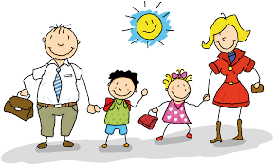

**You are great teachers and have taught your children amazing skills without even knowing it! All we ask is to keep being awesome. Life is so busy and can often get in the way of the simple things that have a huge impact on your children’s future.**

***Did you know?* Reading and talking to your child every day can have a huge impact on their development.**

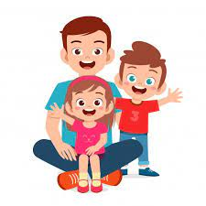

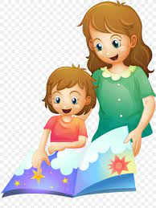

We hope to plan another event to celebrate reading and language in the Summer term. Until then, if you would like to know more about getting children talking there are so many fantastic resources out there:

Talking point is a website all about children’s speech, language and communication. [WWW.talkingpoint.org.uk](http://WWW.talkingpoint.org.uk)

Hungry little minds - gov.uk

Look, say, sing, play NSPCC website

Tiny Happy People -BBC

You are always welcome to chat to us too!

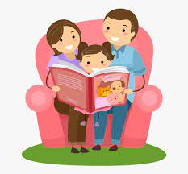

**A huge thank you grown-ups for joining in our Bedtime stories event. It was so lovely to see you enjoying special time with your children and contributing to their language development – without you even realizing it!**

**Bedtime stories, tonight,**

**tomorrow …forever!**

Babies and children **NEED** adults to help them develop speech, language and communication skills but we can develop these life skills in everyday activities.

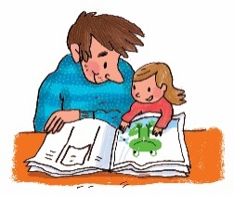

**And if you are still not convinced to find time each day to switch off the TV, phone or iPads take a look at these statistics !!!**

**Even as educators, working with children every day we were still shocked to see the long-term impact poor language skills has on our children.**

*Poor language at the age of 5 means you are 4times more likely to struggle with reading by the age of 11.

*11 times less likely to achieve in maths

*Early language skills at age 5 predicts later emotional outcomes at age of 34

***Good language skills mean better quality friendships and also supports resilience and good mental health.***

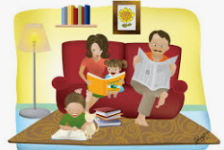

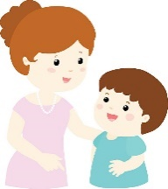

**Remember you are great teachers – even if you don’t realise it.**

**The more you talk to your child, the more words they will learn.**

**Let’s make sure our children are not part of those statistics!**