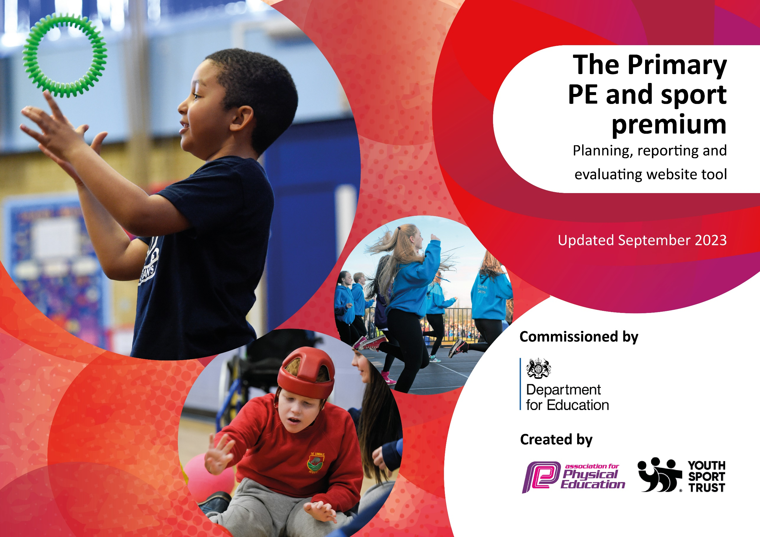

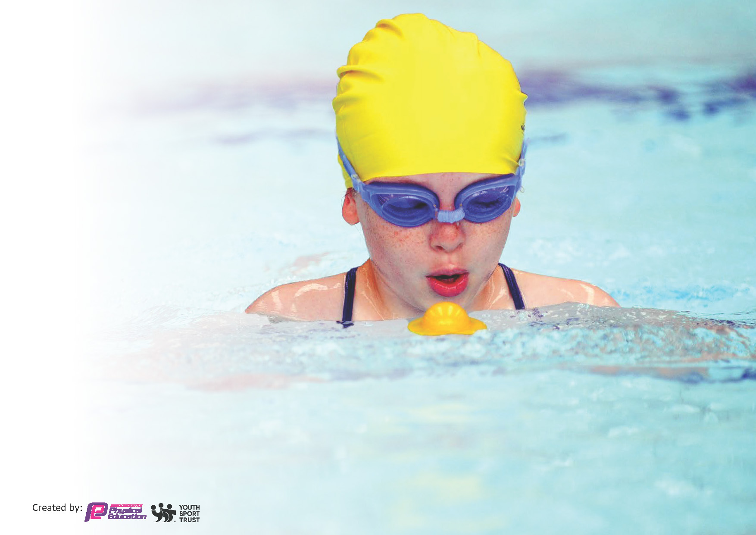
This template can be used for multiple purposes:
by:
- It enables schools to effectively plan their use of the Primary PE and sport premium
- It helps schools to meet the requirements (as set out in guidance) to publish information on their Primary PE and sport premium
- It will be an effective document to support Ofsted inspections enabling schools to evidence progress in Physical Education (PE) and evidence swimming attainment, which forms part of the PE National Curriculum. We would recommend schools consider
the Intent, Implementation and Impact of any spend, as examined within the Education Inspection Framework.

It is important that your grant is used effectively and based on school need.

Schools must use the funding to make additional and sustainable
improvements to the quality of the PE, School Sport and Physical Activity (PESSPA)
they offer. This means that you should use the Primary PE and sport premium to:

- Build capacity and capability within the school to ensure that improvements made now will benefit pupils joining the school in future years
- Develop or add to the PESSPA activities that your school already offers.

The Primary PE and sport premium should not be used to fund capital spend projects; the school’s core budget should fund these. Further detail on capital expenditure can be found in the updated Primary PE and sport premium guidance.

The Primary PE and sport premium guidance, outlines 5 key priorities that funding should be used towards. It is not

necessary that spending has to meet all the key priorities, you should select the priorities that you aim to use any funding towards.

Although completing this template is not a requirement for schools, schools are required to publish details of how they spend this funding. Schools must also outline what the impact this funding has had on pupils’ PE and sport participation and attainment and how any spending will be sustainable in the future. All funding must be spent by 31st July 2025.

The Department for Education has worked closely with the Association for Physical Education (afPE) and the Youth Sport Trust (YST) to develop this template and encourages schools to use it. This template is an effective way of meeting the reporting requirements of the Primary PE and sport premium.
Review of last year’s spend and key achievements (2023/2024)

We recommend you start by reflecting on the impact of current provision and reviewing your previous spend.

Activity/Action | Impact | Comments
New sporting equipment purchased. | The introduction of new sports equipment has significantly increased pupil activity throughout the day. With more resources available during break times, a larger number of students are actively participating in physical activities during their free time. Additionally, PE lessons are now better equipped, offering enhanced learning opportunities across various sports, as the new equipment supports the development of their skills more effectively. | Additional equipment is required to replace outdated items and provide EYFS-specific resources.
Implemented a schoolwide mental wellbeing curriculum. | The schoolwide wellbeing curriculum has empowered pupils to articulate their emotions more clearly, using newly learned vocabulary about brain chemicals. They are more aware of maintaining mental and physical health, actively applying these strategies into daily life. A staff member has been trained across all key stages, ensuring the program's sustainability. As a result, staff are confident with the concepts and language, adapting their lessons to incorporate this inclusive approach effectively. | Next year, the staff member leading these sessions will receive training in the next phase of the Team Up Kids program and deliver it exclusively to KS2. The following year, they will observe and implement the final phase in UKS2.
EYFS progression of motor skills document created; weekly physical activity sessions delivered in nursery and reception. | The EYFS progression of motor skills document has led to more focused and effective physical activity sessions in nursery and reception, with children regularly engaging in activities aimed at developing gross motor skills. Teachers now have clearer guidance on which skills to prioritize in PE lessons and are carefully planning and using the provided resources to deliver impactful sessions. | A new Early Years lead has been appointed and they will ensure the continued implementation of this initiative moving forward.
All pupils have been given the opportunity to participate in a sporting event and to experience a wider range of sports. | All pupils have had the opportunity to participate in at least one external sporting event this year, sparking enthusiasm and encouraging them to practice during breaks, which has increased overall activity levels. Older students have taken part in competitive events, building resilience, confidence, and respect, while demonstrating strong sporting values. Additionally, a variety of sporting experience days have introduced children to a wider range of sports, fostering inclusivity and broadening interest across all abilities. | This year’s school sports day was canceled due to ongoing building works addressing the RAAC-affected areas of the school.
PE ‘basic skills’ curriculum implemented. | A weekly PE lesson focused on developing basic sporting skills has been introduced, with children showing enthusiastic participation and noticeably increased confidence in their abilities. Fitness levels have improved throughout the school, particularly in UKS2, where targeted fitness sessions have been incorporated. | The full impact of these lessons will not be seen until pupils have accessed these lessons over a longer period of time.
PE curriculum developed, with teacher confidence improved | The newly developed PE curriculum offers a diverse range of sporting skills that build progressively each year. Staff training has addressed previously identified areas of low confidence, resulting in more effective PE lessons across all phases. The continued development of sporting skills is reflected in the school’s improved performance in sporting events. | Curriculum to be edited to include areas of sport as yet uncovered, for example target games.

Key priorities and Planning
This planning template will allow schools to accurately plan their spending.

Action – what are you planning to do | Who does this action impact? | Key indicator to meet | Impacts and how sustainability will be achieved? | Cost linked to the action
To employ a dance coach to engage a group of children in after school dance sessions to prepare them to participate in the ‘Primary Dance Festival’. | - Coach (to deliver the dance sessions)  - Pupils (to take part)  - Teachers (to supervise children to and from the competition). | Key Indicator 1 - The engagement of all pupils in regular physical activity.  Key indicator 4: Broader experience of a range of sports and physical activities offered to all pupils  Key indicator 5: Increased participation in competitive sport | Employing a dance coach for after-school sessions will enhance children's physical, social, and emotional development, preparing them for the 'Primary Dance Festival' while fostering teamwork and confidence. Sustainability will be ensured by funding the program through Sports Premium money, allowing for continued access to high-quality coaching and regular integration into the school's extracurricular activities which promotes long-term engagement in dance. | £500
To continue to ensure all pupils are provided with two lessons of curriculum PE each week. | - Teachers  - Teaching assistants (to teach, manage behaviour and observe).  - Pupils (to take part)  - PE Coordinator (to plan the curriculum) | Key Indicator 1 - The engagement of all pupils in regular physical activity. | Providing all pupils with two PE lessons each week ensures regular physical activity and supports overall health. To sustain this, we’ll maintain a structured schedule, allocate adequate resources, and ensure staff are trained, ensuring consistent delivery and ongoing benefits for all students. | £0  GetSet4PE subscription is currently active until 28/02/2027.
New sporting equipment to be purchased to replace older pieces and specific EYFS equipment is needed. | - Teachers (as they will need to be proficient in selecting and using the equipment for their PE lessons)  - Pupils (as they will use and be responsible for the equipment) | Key indicator 1: Engagement of all pupils in regular physical activity  Key indicator 2: The profile of PE and sport is raised across the school as a tool for whole school improvement  Key indicator 4: Broader experience of a range of sports and physical activities offered to all pupils | Purchasing new sporting equipment will enhance physical activities and replace outdated items. To ensure sustainability, we'll select durable and high-quality items. Investing in specific EYFS equipment will support early years' development and ensure long-term benefits for students’ physical education. | £2000
To celebrate sporting achievements in school newsletters/ seesaw. | - Teachers (to share in newsletters/SEESAW).  - Pupils (to share their achievements). | Key Indicator 2 - The profile of PE and sport is raised across the school as a tool for whole-school improvement | Highlighting sporting achievements in school newsletters will boost student motivation and school spirit. To sustain this, we’ll regularly feature diverse accomplishments and ensure consistent coverage, fostering an ongoing culture of recognition and encouragement for all students' athletic efforts. | £0
To give each pupil a chance to participate in sports in different environments. | - Teachers (as they will have to accompany children to and prepare children for the events)  - Pupils (as they will have the opportunity to participate in inter-school competitions)  - PE Coordinator (organize a timetable of events). | Key indicator 5: Increased participation in competitive sport  Key indicator 2: The profile of PE and sport is raised across the school as a tool for whole school improvement  Key indicator 4: Broader experience of a range of sports and physical activities offered to all pupils | Providing each pupil with opportunities to participate in sports in various environments will enhance engagement and skill development. To ensure sustainability, partnerships with diverse sports venues will be established, and feedback will be used to continually adapt and improve the PE curriculum. | £1500 for the DSSP SLA  £1000 for staff cover and transport to competitions.
To embed a schoolwide mental wellbeing curriculum | - Pupils (who will participate in the lessons)  - External provider (to train staff)  - Teachers (who will receive CPD to develop subject knowledge)  - Teaching assistant (who will deliver this scheme of work in the future) | Key indicator 2: The profile of PE and sport is raised across the school as a tool for whole school improvement.  Key indicator 1: The engagement of all pupils in regular physical activity | The schoolwide mental wellbeing curriculum will enhance pupils' emotional and psychological resilience, improving overall wellbeing. Sustainability will be ensured through ongoing staff training and integration into daily routines, with regular reviews to adapt and maintain effectiveness. | £7008 (Go Well SLA)  Brainy Bunch (Go Well SLA).
To embed an Early Years PE scheme of work, to achieve the physical aspects of the Early Learning Goals. | - PE coordinator (arranging meetings and editing necessary documents to include new scheme of work; purchasing necessary resources)  - EYFS team (planning, adapting and delivering scheme of work)  - EYFS children  - EYFS Lead (to ensure the curriculum is being delivered effectively) | Key indicator 1: The engagement of all pupils in regular physical activity  Key indicator 3: Increased confidence, knowledge and skills of all staff in teaching PE and sport  Key indicator 2: The profile of PE and sport is raised across the school as a tool for whole school improvement. | The Early Years PE scheme will enhance physical development, supporting the achievement of Early Learning Goals. Sustainability will be ensured through continuous staff training, regular curriculum updates, and integration into daily activities, ensuring lasting impact and consistent progress. | Move With Max resources (Go Well SLA)  EYFS PE support package (Go Well SLA)
To provide all pupils with the chance to explore a broader variety of sports. | - Coaches (to deliver sport experience days)  - PE coordinator (to arrange dates and timings)  - Pupils (to participate in the sessions) | Key indicator 4: Broader experience of a range of sports and physical activities offered to all | Providing all pupils with the chance to explore a broader variety of sports will foster diverse athletic interests and skills. Sustainability will be achieved through ongoing program updates, staff training, and incorporating new sports into the regular curriculum, ensuring continued engagement and growth. | SMILE days (Go Well SLA)  £500  CREActive  £500  Box 2B Fit  £500  Skip 2B Fit
To develop the fitness sessions delivered to UKS2. | - Teaching Assistants (who deliver the sessions)  - PE Coordinator (to arrange any CPD for staff)  - Pupils (to participate in the sessions) | Key indicator 1: The engagement of all pupils in regular physical activity  Key indicator 3: Increased confidence, knowledge and skills of all staff in teaching PE and sport  Key indicator 2: The profile of PE and sport is raised across the school as a tool for whole school improvement. | Subscribing to the Fit for Life program will engage primary school children in fun, age-appropriate fitness activities, promoting physical health and well-being. This will foster healthy habits from a young age. To sustain this, we’ll provide tailored guidance, regularly assess progress, and educate children on maintaining active lifestyles both at school and home. | Fit For Life Program (Go Well SLA)
To develop the ‘Outdoor Adventurous Activities (OAA)’ element of the PE curriculum. | - External agencies (to deliver OAA sessions to the children)  - PE coordinator (to arrange dates and timings)  - Pupils (to participate in the sessions) | Key indicator 1: The engagement of all pupils in regular physical activity  Key indicator 2: The profile of PE and sport is raised across the school as a tool for whole school improvement.  Key indicator 4: Broader experience of a range of sports and physical activities offered to all | Developing the ‘Outdoor Adventurous Activities (OAA)’ element of the PE curriculum will enhance pupils' problem-solving and teamwork skills. Sustainability will be ensured through ongoing updates to the curriculum, regular staff training, and consistent assessment, keeping the activities engaging and effective long-term. | Thrills and Skills OAA Day (Go Well SLA)
To offer equal opportunities to all pupils to participate in after school clubs/activities. | - Coaches (to deliver the sessions)  - Pupils (to attend the sessions)  - PE Coordinator (to plan after school club sessions). | Key Indicator 1 - The engagement of all pupils in regular physical activity.  Key indicator 4: Broader experience of a range of sports and physical activities offered to all pupils  Key indicator 5: Increased participation in competitive sport | Professional football coaches will train boys’, girls’, and development teams, enhancing pupils' skills, teamwork, and confidence in preparation for inter-school competition. By fostering a strong culture of football within the school, encouraging staff involvement, and developing student leaders, we aim to maintain interest and participation in future teams and competitions. | £4500  Martin Gray Football Academy

Key achievements 2024-2025
This template will be completed at the end of the academic year and will showcase the key achievements schools have made with their Primary PE and sport premium spending.

Activity/Action | Impact | Comments

Swimming Data
Meeting National Curriculum requirements for swimming and water safety.
Priority should always be given to ensuring that pupils can perform safe self-rescue even if they do not fully meet the first two requirements of the National Curriculum programme of study

Question | Stats: | Further context  Relative to local challenges
What percentage of your current Year 6 cohort can swim competently, confidently and proficiently over a distance of at least 25 metres? | % | Use this text box to give further context behind the percentage.  e.g., 30% - we are struggling to get pool space due to our local pool closing so we have had to use a much smaller local school pool. We have had to limit the number of pupils attending swimming lessons during one term which means some pupils have attended fewer swimming lessons than others.
What percentage of your current Year 6 cohort can use a range of strokes effectively [for example, front crawl, backstroke, and breaststroke]? | % | Use this text box to give further context behind the percentage.  e.g., Even though your pupils may swim in another year please report on their attainment on leaving primary school at the end of the summer term 2024

What percentage of your current Year 6 cohort are able to perform safe self-rescue in different water-based situations? | % | Use this text box to give further context behind the percentage.
If your schools swimming data is below national expectation, you can choose to use the Primary PE and sport premium to provide additional top-up sessions for those pupils that did not meet National Curriculum  requirements after the completion of core lessons. Have you done this? | Yes/No
Have you provided CPD to improve the knowledge and confidence of staff to be able to teach swimming and water safety? | Yes/No

Signed off by:

Head Teacher: | (Name)
Subject Leader or the individual responsible for the Primary PE and sport premium: | (Name and Job Title)
Governor: | (Name and Role)
Date:

