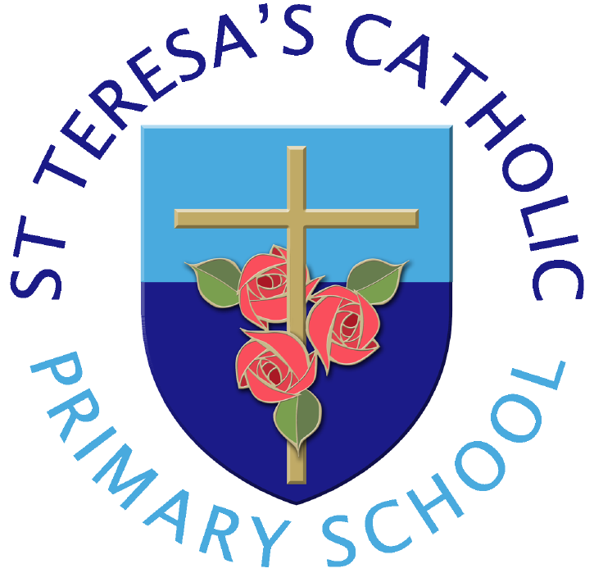
“Live, Love and Learn”

St Teresa’s Catholic Primary School -
Mater Ecclesiae Catholic Multi-Academy Trust
Determined Admissions Policy
September 2026

We are made in the image of God
to live, love and learn in a caring Catholic community,
where tolerance, confidence and independence are nurtured
and every achievement makes us proud.

St Teresa’s is a Catholic School in the trusteeship of the Diocese of Lancaster. It is maintained by Lancashire Local Authority and is a voluntary aided School. Governing Body is the Admissions Authority and is responsible for taking all decisions on applications for admissions. The co-ordination of admissions arrangements is undertaken by the Local Authority.

St Teresa’s is a Catholic School in the trusteeship of the Diocese of Lancaster and part of Mater Ecclesiae Catholic Multi Academy. The Governing Body is the Admissions Authority and is responsible for taking all decisions on applications for admissions. The co-ordination of admissions arrangements is undertaken by the Local Authority.
The Governors welcome applications from Catholic and Non-Catholic parents who would like their children educated within the aims and ethos of Mater Ecclesiae Catholic Multi-Academy Trust and St. Teresa’s Catholic Primary School.
St. Teresa’s is a Catholic Primary School in which the Catholic faith and the teachings of the Catholic Church are important aspects of school life and influence the school curriculum.
We ask all parents applying for a place here to respect this ethos and its importance to the school community. This does not affect the right of parents who are not of the faith of this school to apply for and be considered for a place here.
The school’s role is to participate in the mission of the Catholic Church by providing a curriculum, including Catholic religious education and worship, which will help children to grow in their understanding of the Good News and in the practice of their faith. The school will help the children develop fully as human beings and prepare them to undertake their responsibilities as Catholics in society. The school requires all parents applying for a place here to understand and respect this ethos and its importance to the school community. This does not affect the rights of parents who are not of the Catholic faith to apply for a place here.

Admissions will be determined by the Governing Body. If you wish to have your application considered against that school's religious criteria then you must ALSO complete the Supplementary Form which is at the end of this policy (page 5).
The number of places available for admission to the Reception Class each year is 30.

Applications can be made online at www.lancashire.gov.uk/schools
As required by law all children with a Statement of Special Educational Needs or an Education and Health Care Plan (EHCP) naming the school will be admitted before the application of the oversubscription criteria.
If there are fewer than 30 applications, all applicants will be offered places. Where more applications are received than the planned admissions number for the school, the oversubscription criteria will be applied in the following order:
1. Looked After Children, previously Looked After Children and internationally adopted children.
2. Baptised Catholic children who have a sibling in the school at the time of admission.
3. Baptised Catholic children resident in the former parish of Saint John XXIII
4. Other baptised Catholic children.
5. Other children who have a sibling in the school at the time of admission.
6. All remaining applicants.
If it is not possible to offer places for all applications within any criterion above, priority will be given to those living closest to the school measured by the straight-line distance from the centre of the school building to the centre of the applicant's home address. In the event of distances being the same for two or more applicants, places will be allocated by means of a fair random draw
Notes for Applicants:
- All applications will be considered at the same time and after the closing date for admissions which is 15 January 2026. Applications received after this date will be treated as a late application and will not be considered until after the main allocation of places has taken place. Late applications may not necessarily be considered with those who applied on time by the governing body.
The governing body will decide whether to consider late applications based upon whether there is a genuine reason for the lateness of the application e.g. moving into the area after the closing date or having a genuine medical reason for being unable to complete the application on time.
Acceptable evidence would be deemed to be conclusive proof that you are moving into the area i.e. a proof of job offer on official company stationery from the company offering the job or a solicitor’s letter showing proof of an accepted offer on a residency within one of the above parishes accompanied by proof of a mortgage offer from a lender
b. Looked after children: This category includes: looked after children or a child who was previously looked after, but immediately after being looked after became subject to an adoption, child arrangement order, or special guardianship order or those children who appear to the school to have been in state care outside of England and ceased to be in state care as a result of being adopted.
- For a child to be considered as a Catholic evidence of a Catholic Baptism is required.
A person who has been baptised in a separate ecclesial community and subsequently received into full communion with the Catholic Church by the Rite of Reception of Baptised Christians into the Full Communion of the Catholic Church. Written evidence of their reception into full communion with the Catholic Church can be obtained by recourse to the Register of Receptions, or in some cases a sub-section of the Baptismal Registers of the Church in which the Rite of Reception took place.
The Governing Body will require written evidence in the form of a Certificate of Reception before applications for school places can be considered for categories of ‘Baptised Catholics’. A Certificate of Reception is to include full name, date of birth, date of reception and parent(s) name(s). The certificate must also show that it is copied from the records kept by the place of reception.
Those who have difficulty obtaining written evidence of baptism for a good reason, may still be considered as baptised Catholics but only after they have been referred to the parish priest who, after consulting with the Lancaster Diocese, will decide how the question of baptism is to be resolved and how written evidence is to be produced in accordance with the law of the Church.
d. Home Address is considered to be the address where the child normally lives. Where care is split and a child moves between two addresses, the household in receipt of the child benefit would normally be the address used but the admission authority body reserves the right to request other evidence as fit the individual circumstance. Applicants should not state the address of another relative or person who has daily care of the child.
- ‘Sibling’ is defined in these arrangements as full, half or step brothers and sisters, adopted and foster brothers and sisters who are living at the same address and are part of the same family unit. This does not include cousins or other family relationships.
- A waiting list for children who have not been offered a place will be kept and will be ranked according to the Admission Criteria. The waiting list does not consider the date the application was received or the length of time a child's name has been on the waiting list. This means that a child's position on the list may change if another applicant is refused a place and their child has higher priority in the admissions criteria.
- For ‘In Year’ applications received outside the normal admissions round, if places are available they will be offered to those who apply. The data collection form is on the website and must be completed and returned to school. If there are places available but more applicants than places then the published oversubscription criteria will be applied. Parents will be notified within 10-15 days regarding the outcomes of their application and reasons if unsuccessful.
- If an application for admission has been turned down by the Governing Body, parents may appeal to an Independent Appeals Panel. Parents must be allowed at least twenty school days from the date of notification that their application was unsuccessful to submit that appeal. Parents must give reasons for appealing in writing and the decision of the Appeals Panel is binding on the Governors.
- The Governing Body reserve the right to withdraw the offer of a school place where false evidence is received in relation to the application.
- It is the duty of governors to comply with regulations on class size limits for children aged between rising five and seven. The Governing Body may exceed the regulations for twins and children from multiple births where one of the children is the 30th child admitted. This also applies to in-year applicants who are looked after/previously looked after, internationally adopted previously looked after children, children of UK service personnel or children who move into the area for whom there is no other school available within a reasonable distance.
- If a child is a “summer born child”, parents may request that the date their child is admitted to school is deferred to later in the school year. However, the child must start school before the end of that school year. If a parent wishes their child to be educated out of their normal school year (kept back a year), they must discuss this with the school before applying. However, the final decision on this rests with the headteacher.
- Parents may request that their child attend school part-time until he/she reaches his/her fifth birthday.
SUPPLEMENTARY INFORMATION

Please complete this supplementary information form carefully. The information provided will be used by the Governors to apply the school's admission criteria.
Details for child
Surname: |  | Legal Surname:
Forenames: |  | Middle name:
Date of Birth: |  | Gender:
Home Address:
Post Code: |  | Telephone:
Name of Parent/Guardian |  |  | Please tick one box Parent Guardian
Address if different from above
Names of other siblings attending St Teresas at the time of application
Religion of prospective pupil
Name and address of place of Baptism
 |  | Postcode
Date of Baptism |  | Copy of confirmation of Baptism attached
Signed |  | Date:
Print name

Please return this completed form, together with a copy of your child’s confirmation of Baptism, to the Headteacher, St Teresa’s Catholic Primary School, Downing Street, PR1 4RH.

Please note that failure to attach confirmation of Baptism may result in your application for a place being considered against a lower priority admission criteria.

