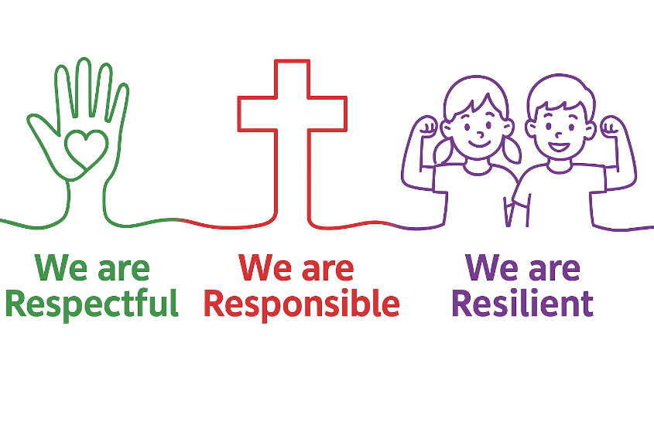


St Teresa’s Catholic Primary School Anti-Bullying Policy

Definition of Bullying:

At St Teresa’s we follow the Department for Education’s guidance, which recognises that there is no single legal definition of bullying. However, bullying is generally understood to be:
- Repeated behaviour
- Intended to hurt someone either physically or emotionally
- Often targeted at individuals or groups because of characteristics such as race, religion, gender, sexual orientation, or disability

Bullying can take many forms, including:
- Physical assault
- Teasing or name-calling
- Making threats
- Cyberbullying (via mobile phone, email, social media, or messaging platforms)

The NSPCC also emphasises that bullying is behaviour that is deliberate and happens over a period of time. One-off incidents of unkindness, aggression, or conflict are taken seriously and dealt with appropriately, but they are not considered bullying unless they are repeated and targeted in line with the above definition.

At our school bullying behaviour is unacceptable and will not be tolerated. We encourage children to work against it and to report any incidents of bullying. Through assemblies, PSHE, circle time, class worship and discussion times, pupils are made aware of the school’s anti-bullying policy.

Emphasis is placed on the fact that action on bullying can only be taken if is brought to someone’s attention. The school promises its pupils that it will act positively in all instances of bullying. Whenever appropriate, the parents of the person who is ‘bullying’ will be involved and kept closely informed about the situations. Sanctions for bullying will usually be appropriate to the nature of the incident. All cases should be treated with the utmost sensitivity.

St Teresa’s Procedures on Dealing with Bullying Incidents
    - If a member of staff is witness to a bullying incident or one is brought to their attention they must report it to the Headteacher / Deputy Headteacher or Senior Leader and bullying incidents are logged on the CPOMS system to monitor.
    - If an accusation is made by parents about their child being a victim of bullying the Headteacher always asks for time to monitor the situation. This allows the Headteacher time to interview the alleged ‘victim’ first, next the alleged ‘bully’ then involve and pupils any adults who may have information and then the situation is monitored closely e.g. playtime observations. The Headteacher will always feed back to the parents on their findings and actions taken, resulting outcome and ways forward.
    - All incidents of unkindness, aggression or conflict are recorded on CPOMS. If the same child is found to have targeted the same individual or group on three or more occasions, this will be considered as evidence of bullying behaviour. At this point, a meeting will be arranged with the child’s parents/carers to discuss concerns and agree next steps.
    - Serious incidents may be treated as bullying even if they occur fewer than three times, at the discretion of senior staff.

Dealing with Bullying Incidents (guidance)
- Remain calm and avoid over-reacting, even though you may feel sympathy for the victim or frustration towards the child who has bullied.
- Focus on the behaviour, not the child – make it clear that the actions are unacceptable, not the individual.
- Avoid shouting; raising your voice can escalate the situation.
- Maintain a respectful tone: use names, positive body language, and a calm manner.
- Keep control of the conversation – do not allow the child to deflect responsibility onto others.
- Be fair and solution-focused: work towards agreements and strategies for change.
- Provide support for both the victim and the child who has bullied. Victims need help rebuilding self-esteem and confidence; the child who has bullied may need support to develop cooperation, empathy, and self-control.
- Never respond to bullying behaviour by “bullying the bully.” Instead, seek to understand the reasons for the behaviour and address them constructively.

Role of the Headteacher and Governing Body
The school will fulfil its legal duty of care to ensure its pupils do not come to harm. This includes the reporting of all bullying incidents which have been identified as such, using the policy definition. This reporting is done by the Headteacher to the governing body on a termly basis.

Dissemination of the policy
The policy is to be used as a key vehicle for communicating and celebrating the anti-bullying stance of the school with pupils, parents and the wider community. The school incorporates the anti-bullying policy into staff handbooks, the school’s behaviour policy, the school’s child protection and safeguarding policy, the school curriculum and whole school assemblies, all school staff training as well as taking on board other opportunities to raise awareness e.g. anti bullying week, targeted group work and through the school’s behaviour promises: We are Respectful, We are Responsible and We are Resilient . The policy is made available on the school website.

Procedures for monitoring and evaluation of policy

The school will monitor and evaluate bullying by:
- Keeping records of all incidents. This is done via the CPOMS system
- Pupil focus groups
- Annual Pupil and Parent Questionnaires
- Parental complaints, records of complaint logged
- Discussions at staff/SLT/ meetings
- Headteacher reports to the Governing body

Links with other relevant policies
- PSHE,
- Behaviour Policy
- Child Protection and Safeguarding Policy
- Online safety

Named member of staff responsible for dealing with anti-bullying incidents

The person responsible for all bullying incidents in school is the Headteacher.

Parental support for all pupils involved in bullying incidents

The school endeavours to have open and supportive communication with parents in relation to all bullying incidents. Parents who are concerned that their child may be being bullied, or who may suspect that their child may be the perpetrator of bullying, should contact the class teacher immediately. Parents have a responsibility to support the school’s anti-bullying policy and to actively encourage their child to be a positive member of the school.

Curriculum Content that supports the anti-bullying programme
- Personal, Social, Health Education
- Religious Education and Pastoral care
- Circle time activities
- Whole school assemblies
- Multi-agency working e.g. NSPCC
- Anti-bullying themed activities

Approved by | Governors
Date | September 2025
Review | September 2027

