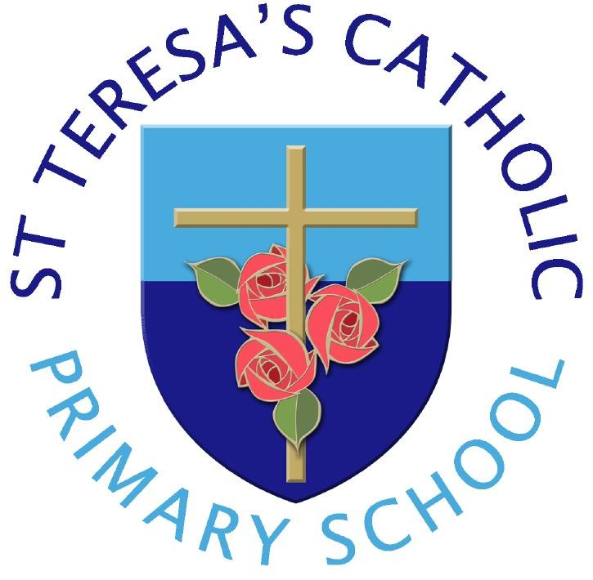

St Teresa’s Catholic Primary School
Charging and Remissions Policy
“Live, Love and Learn”

We are made in the image of God
to live, love and learn in a caring Catholic community, where tolerance, confidence and independence are nurtured
and every achievement makes us proud.

INTRODUCTION
This charging and remissions policy complies with statutory requirements, has regard to the Authority's policy statements on charging and is reviewed on a bi-annual basis.

CHARGING POLICY Activities without charge
All education during school hours at St Teresa’s is free. We do not charge for any activity undertaken as part of the school curriculum.
There will be no charge for the following activities:
- education provided wholly or mostly during school hours. This includes the supply of any materials, books, instruments, other equipment and also transport provided in school hours to carry pupils between the school and an activity;
- education provided outside school hours if it is part of the National Curriculum, or part of a syllabus for a prescribed public examination which the pupil is being prepared for at the school, or part of religious education;
- instrumental and vocal music tuition which is part of the National Curriculum or the first programme in which the whole class engages with the KS2 Programme of Instrumental and Vocal Tuition (Wider Opportunities);
- instrumental and vocal tuition for children in care;
- entry for a prescribed public examination including re-sits provided that a pupil has been prepared for it at the school.

Voluntary Contributions
When organising school trips or visits to enrich the curriculum and the educational experience of the children, the school invites parents to contribute to the cost. All contributions are voluntary. If we do not receive sufficient voluntary contributions, we may have to cancel a trip. If a trip goes ahead, it may include children whose parents have not paid any contribution. We do not treat these children differently from any others. Sometimes the school pays additional costs in order to support the visit. Parents have a right to know how each trip is funded. The school provides this information on request.
The following is a list of additional activities, organised by the school, which may require voluntary contributions from parents. These activities are known as ‘optional extras’. This list is not exhaustive:
- visits to museums;
- sporting activities which require transport expenses;
- outdoor adventure activities; • visits to or by a theatre company;
- musical events.

Chargeable Activities
The school may recover the full costs of the following activities but charges will not exceed actual cost:
- educational or other activities provided wholly or mainly outside school hours which are not:
  - part of the National Curriculum;
  - part of a syllabus for a prescribed public examination which the pupil is being prepared for at school;
  - part of religious education.
- board and lodgings on residential visits (subject to remission arrangements).
- provision of instrumental and vocal tuition, which takes place during the school day and which has been requested by parents/carers.
- day care facilities

Activities, excursions and Special Visiting Groups
The school may request payment towards the cost of some activities planned during school hours. Parents will be informed of this as far as possible in advance and is practicable for administration purposes.
- Our annual residential trip incurs a cost to parents that is spread over 9 months. The charge covers the cost of transport, board and lodgings at the actual cost to the school.
- The school will absorb a proportion of the cost for Pupil Premium Children and for twins for some school trips and residential trips. The school may also absorb a proportion of the cost for such trips where the school is aware that the family may be unable to meet the cost of the trip.
- Nominal charges may be made for pupils attending After School clubs.
- Where music tuition or singing tuition is not an essential part of the National Curriculum, charges may be made.

School Dinners
The school kitchen is managed by Lancashire County Council and the price per school meal is charged to parents at £2.90 a day or £14.50 a week from 26/04/2025.
School Meals are charged via the ParentPay system.
- Children registered in the Pupil Premium scheme and whose parents are in receipt of government support payments are entitled to a free school meal each day.
- Children in Reception and KS1 are entitled to receive a ‘free’ meal under the Universal free school meal offer.
- Where special events are planned; such as Christmas Lunches, we require parents to make their choices clearly in advance and no later than return dates stated in
letters/ communications/ advertisements to ensure there will be a meal for their child. Again this is a requirement of advance planning and catering to order the correct number of meals.

Breakfast Club
Breakfast Club We have an on-site before school breakfast club which runs from 8am to 8:40am every school morning. As this is outside of education hours a fee of £1 per pupil per session is charged. This is payable through parent pay.

Administration Charges
Where a parent requests certain documents or certification of formal paperwork/ agreements and the school is charged for these services, the reasonable costs to the school will be passed directly to the parent. This is unusual, but the School reserves the right to pass on any unexpected costs presented on behalf of any parent. The School will charge £10 for completing and signing passport applications. This service is provided at the discretion of the individual teacher or Headteacher

Uncollected Children
A charge may be made for children who are collected late from school. The parent/carer will be sent a letter reminding them to collect their child from school at 3:10pm if they are late more than twice in a fortnight (2 weeks). From there on in, in cases where a child is not collected within ten minutes of the end of the school day (3:20pm onwards) there will be a charge of £7 per child. A further charge of £5 per child for every 5 minutes will be charged after this time.

Charging for lost or damaged property
In the event of school property being lost or damaged then the parents shall be asked to contribute towards the cost of replacement. The cost of the replacement of a child’s reading book is £4.00, a school reading record is £1.00 and any replacement badges are £1.50.

Vandalism and or Damages
Any person who causes damage to the school resources/premises/materials/fabric of the building will be asked to make payment for any damages/loss/theft caused. Within the procedure of securing “Best Value”, the school will seek out the most economical means of replacing same-for-same. Similarly, if anyone causes damage or loss to another individual’s personal property, the school will take steps to attempt to recover the loss which may incur a cost to the family of the individual who may have caused the incident.

Remissions Policy
• There will be no charge for board and lodgings for pupils whose parents are receiving income support, income-based job seekers allowance, family credit or disability working

P
a
r
i
s
h
o
f
S
t
J
o
h
n
X
X
I
I
I
allowance. Charges for other 'chargeable activities' may also be fully or partly remitted. Details of any remission arrangements will be made clear when parents are informed of charges for individual activities.

Reviewed January 2025
Next review date January 2027

