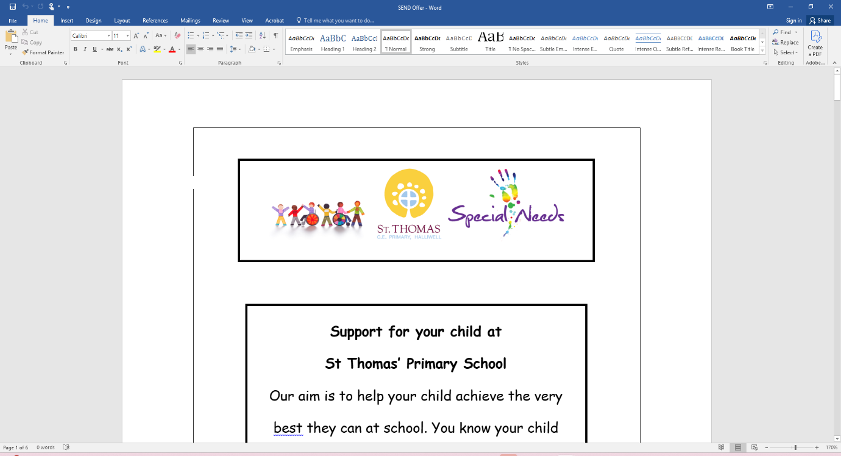
SEND Information Report
Date Approved: September 2025
Date For Review: September 2026
SENCO: Mrs Welsh

St Thomas Halliwell C.E Primary School is dedicated to fostering an inclusive environment where the aspirations and expectations of every student, including those with Special Educational Needs and Disabilities (SEND), are supported and elevated. We recognise and celebrate the talents and accomplishments of all our pupils, striving to create an optimal learning environment that promotes positive educational outcomes. Our approach to SEND support is holistic, involving the entire pupil and the whole school, and is focused on ensuring every child is included, regardless of their individual needs.

We deeply value every child and family in our community and embrace the richness that diversity brings. Our shared commitment is that all students, no matter their specific requirements, receive high-quality provision that enables them to progress effectively and feel respected and included in the school community.

At St Thomas Halliwell, we are committed to recognising the strengths of all our pupils. It is our responsibility to provide each individual in our care with equal opportunities, within a secure and well-resourced learning environment tailored to meet their personal needs. Our goal is to help every child achieve success and reach their full potential by offering exceptional education and support.

Our mission at St Thomas Halliwell is to celebrate and support diversity, providing tailored educational experiences through Quality First Teaching and inclusive provisions, embodying our belief that everyone has the opportunity to
‘Let Your Light Shine’.

The school is fully committed to helping pupils with SEND realise their abilities and attain the best possible academic outcomes.

The SEND Code of Practice (2015) says:
All children and young people are entitled to an appropriate education, one that is appropriate to their needs, promotes high standards and the fulfilment of potential.
This should enable them to:
• achieve their best
• become confident individuals living fulfilling lives, and
• make a successful transition into adulthood, whether into employment, further or higher education or training

We are committed to promoting the full inclusion of all students by addressing their individual needs. Every child is entitled to access a broad and balanced curriculum, and our SEND policy emphasises the importance of delivering high-quality, inclusive teaching. The Governing Body will ensure that appropriate resources and provisions are in place to support all pupils with SEND.
Pupils identified as SEND are identified as having needs within one or more of the areas below:
• Communication and Interaction
• Cognition and Learning
• Sensory and/or Physical
• Social, Emotional and Mental Health Needs

How does St Thomas Halliwell know if your child requires extra support?
The SEND Code of Practice (2015) defines the identification of SEND as:
A child or young person has SEN if they have a learning difficulty or disability which calls for
special educational provision to be made for him or her.
A child of compulsory school age or a young person has a learning difficulty or disability if he
or she:
• has a significantly greater difficulty in learning than the majority of others of the
same age, or
• has a disability which prevents or hinders him or her from making use of facilities of a
kind generally provided for others of the same age in mainstream schools or
mainstream post

The first stage of support in school and early identification is provided through SEND Support (Assess, Plan, Do, Review). At this stage, high-quality teaching strategies are integrated into classroom routines to address pupils' needs, and any initial concerns are shared with parents or carers. If a child's needs go beyond what can be met through these initial strategies, the school will hold a follow-up meeting with parents or carers to consider the next steps. This could involve extra interventions within school or seeking guidance from Local Authority professionals such as Woodbridge SEND Service, Educational Psychologists, Speech and language therapist, Aspire (behaviour), CAMHS. In some cases, this process may lead to an application for an Education, Health and Care Plan (EHCP).

How will the school support my child?
At St Thomas’ the progress and attainment of all pupils is reviewed every half term by the Senior Leadership Team alongside class teachers. Additional interventions will be agreed to meet any needs identified at this time.
If a child continues to have difficulties after targeted intervention or has a high level of difficulty when they join school, they may be considered to have a special educational need (SEND) and placed on the SEND register. Parents will be informed of this.
SEN Stages
The Special Educational Needs Code of Practice gives guidance to schools in meeting the needs of pupils. It sets out how help should be given in a step-by-step approach. You will be consulted at all stages of this graduated approach and staff will inform you of the additional work they do with your child.
Class teachers will assess your child to identify their strengths, needs and the extra help they require. If they need extra or different support than most children, their age they may be placed at:
SEN Category (K) This may involve:
- extra help from a teaching assistant in class
- small group or individual support out of class planned for by the class teacher
- specialist resources such as a sloping board, ICT access, visual prompts.
- Pastoral Support
If your child continues to have difficulty even with this extra support, we will seek professional advice from:
- Speech and language therapists
- Woodbridge SEND Service
- Sensory teachers
- Health professionals
- Educational psychologists
Education, Health and Care Plans
If your child’s needs are complex or severe we may suggest that we ask the Local Authority for a Statutory Assessment. This document will describe your child’s SEN and the specialist help they should receive.
Education, Health and Care Plans usually involve the Local Authority providing extra resources to help your child. These resources could include money, staff time, special equipment and attendance at a school with specialist resourced support. This additional provision will be reviewed annually and would include parent/carer, teacher, SENCO, specialist support and the pupil.

How will I know how well my child is doing?
Parents will be informed of their child’s progress in the autumn and spring term at parent’s evenings. A written report will be sent home at the end of the summer term. Further meetings will be held with parents to discuss any additional Special Needs support, assessments, outside agencies interventions or to review outcomes through early help meeting reviews. Where a child has an Education, Health and Care Plan, an annual review will be carried out, annually with all outside agencies involved.

How will the school’s approach to teaching and learning be matched to my child’s needs?
At St Thomas Halliwell, we believe that every child can achieve and thrive through high-quality, adaptive teaching. Our approach ensures that all pupils- including those with SEND are able to access learning, participate fully, and make strong progress. The school follows the assess, plan, do, review process.
Our adaptive teaching approach is grounded in equity, inclusion and high expectations. Teachers adapt their teaching to respond to the strengths and needs of all pupils, ensuring that all pupils can achieve and succeed
Effective adaptive teaching includes knowing each learner well and responding flexibly to their needs.
- Language Support: Visuals, sentence starters, word mats, bilingual dictionaries, pre-teaching of key vocabulary, and explicit vocabulary modelling.
- Scaffolding: Chunked instructions, modelling, worked examples, guided practice, and talk frames.
- Cognitive Challenge: Tasks pitched to the same learning objective/outcome for all pupils, with adjusted scaffolds rather than reduced expectations. Opportunities for overlearning and repetition.
- Use of Talk: Structured talk activities, teacher modelling of academic language, and oral rehearsal before writing.
- Feedback: Verbal and visual feedback focused on clarity, rephrasing and next steps.
- Groupings: Flexible grouping to balance peer language models and opportunities for first language use.
- Incorporate real life, practical activities: All leaners can actively participate and succeed, through trips, visitors and practical approaches to learning.
- Encourage peer learning and collaboration: Creating opportunities for students to learn from and support one another.

What support is there in school to help my child with their worries, mental health, behaviour and social needs?

Our pastoral support officer (Mrs Powell) provides support for pupils’ well-being, personal development, and behaviour. Her role focuses on helping students feel safe, supported, and ready to learn by addressing any barriers that may affect their education, such as emotional, social, or behavioural issues.
Key responsibilities typically include:
- Supporting children’s mental health and emotional needs
- Monitoring attendance and punctuality
- Helping manage behaviour and resolving conflicts
- Working with families to support children at home and in school
- Liaising with external agencies (e.g., social services, counselling)
- Providing a trusted adult figure for children to talk to
Overall, our pastoral support officer helps create a positive school environment where all children can thrive personally and academically.
Our pastoral support officer may work with your child on a 1:1 basis outside, or in the classroom. They may also be supported in small group interventions. This will then be reviewed with the class teacher and parents termly.
What specialist services and expertise are available at or accessed by school? School may seek additional support and specialist support to help your child inside and outside of school. Some of the agencies and specialist that school have access to are;
- Woodbridge SEND Service
- The Nest (Speech and Language Therapist)
- Sensory Support
- BSCIP
- Aspire
- Bright Leaders
- Educational Psychologist
- Speech and language therapy
- Community Paediatrician
- School Nurse
- Health Visitor
- Occupational Therapist
- Child and Mental Health Service (CAMHS)
- Targeted Youth Service
- Bolton Parent Partnership
- Learning Disability Support Team
- SEND Assessment Officers (LA)
How will you help me support my child outside of school?
The school's website provides details on homework expectations for all year groups and key stages. If a pupil requires modified learning tasks, the class teacher will adapt homework to suit their individual needs. Should a pupil find it difficult to complete tasks at home, parents are encouraged to speak with the class teacher or SENDCo to find the most effective way to support their child. For pupils who are not following a subject-specific curriculum, the class teacher will work with parents or carers to set appropriate learning targets based on the pupil’s needs and abilities.
How does the school enable constructive partnership working with families? In line with the SEND Code of Practice (2015), parents and carers are encouraged to seek additional guidance from SENDAC or SENDIASS for support relating to their child’s SEND needs and provision. St Thomas Halliwell values open and ongoing communication with families, offering regular opportunities for parents to meet and discuss their child’s progress. When other external agencies are involved, parents are invited to attend meetings to receive feedback and contribute to planning the next steps in their child’s support. The school ensures that parental views are heard and considered.

Who can I contact for further information?
Your child’s class teacher is the first contact within school. If you would like further information regarding support/provision/needs for your child an appointment can be made with Mrs Welsh (SENCo) by contacting the school office.

How will the school prepare and support my child to join the school, transfer to a new
school or the next stage in education or life?
Within the Early Years environment, our Early Years team will liaise with parents and nursery staff to ensure that pupils, starting school with additional needs have enhanced transition periods and access to support within the setting. Extra meetings are provided for parents to meet with staff and plan provision.

At St Thomas Halliwell every effort is taken to ensure transition times are successfully managed to maintain continuity of provision from year to year and key stage to key stage. Every child has an opportunity to meet with their new teacher in their new classroom at the end of each year. Additional visits are also arranged to re-assure pupils and parents.
Links with our local secondary schools are also very good. Staff from the schools which pupils are transferring to, meet with school prior to the end of the transition; this ensures that all staff are aware of the needs of our pupils and can make adequate arrangements in readiness for the transition to high school. In preparation for the transition, the school encourages that parent/carers engage with both schools to ensure a smooth transition. School staff will arrange a meeting with parents/carers and both schools to ensure a smooth transition. In the case of Year 6 pupils, the SENDCo will arrange enhanced transition visits to the next school and liaise with the high school SENDCo.

How are decisions made about the range of support my child will receive?
At St Thomas Halliwell, support for pupils is determined through the graduated approach—assess, plan, do, review. When concerns are raised, they are first discussed with parents or carers and then with the SENCo. The type of support offered is based on the pupils’ academic level and any identified pastoral, social, or emotional needs. Following discussion with parents, appropriate interventions are arranged, and if necessary an early help assessment is opened and targets are set and reviewed termly. If school staff believe that additional support may be required a further meeting will be held with parents and the SENCo to review and plan the next steps.

Some of the interventions that are offered by St Thomas Halliwell are:
- Pastoral Support
- Bright Leaders
- The Nest Speech and Language Therapist
- Maths/English interventions
- Reading Plus
- Specific 1:1 interventions working on personalised targets
- Speech, language and communication programmes
- 1:1 Read Write Inc Tutoring
- Attention Autism

Support in school can vary between 1:1 support, group interventions and group support within class. In some cases where a pupil is not engaged in subject specific study, there is collaboration between outside agencies, the local authority, parents/carers and school staff to plan and ensure the needs of pupils are being met.

Where can I find out about the local authority’s local offer of services and provision for
children and young people with SEND? The Local Offer provides a single point for information to help families access details about services available to them, and offer guidance in multiple areas, such as:
- Early years places
- Schools (including academies and free schools)
- Colleges
- Health and care
- Leisure activities

Bolton SEND Local Offer can be found by clicking the link below.
https://www.bolton.gov.uk/sendlocaloffer/

