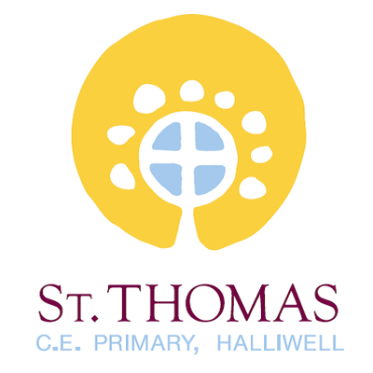

Support for your child at
St Thomas’ Primary School
Our aim is to help your child achieve the very
best they can at school. You know your child
best and you may feel that they need some
additional help or support for some or all of
their time at school.
This booklet is to inform you of the types of
support available for your child at St Thomas’.
It will help you understand who
can help and how this support can be accessed.

All pupils in school receive quality first teaching. This means that a range of teaching and learning styles are used and that appropriate learning objectives are set for all children with a curriculum matched to their needs. All our classes are supported by teaching assistants who work with individual or small groups of children directed by the class teacher.

At St Thomas’ the progress and attainment of all pupils is reviewed every half term by the Senior Leadership Team alongside class teachers. Additional interventions will be agreed to meet any needs identified at this time.

You will be informed about your child’s general progress and targets through the twice yearly Parents Evening and end of year written report.

If a child continues to have difficulties after targeted intervention or has a high level of difficulty when they join school, they may be considered to have a special educational need (SEND) and placed on the SEND register. Parents will be informed of this.


Children with SEND have learning difficulties and/or physical disabilities which make it harder for them to learn than most children of the same age.
Schools and other agencies can help most children overcome their difficulties quickly and easily. But a few children will need extra help for some or all of their time in school.
This means they may have difficulty with:
- some or all of the work in school
- reading, writing or mathematics
- understanding information
- expressing themselves
- understanding others
- organising themselves
- sensory perception or physical mobility
- managing their behaviour
- making friends or relating to adults

At St Thomas’ every effort is taken to ensure transition times are successfully managed to maintain continuity of provision from year to year and key stage to key stage.
Every child has an opportunity to meet with their new teacher in their new classroom at the end of each year. Additional visits are also arranged to re-assure pupils and parents.


SEN Stages
The Special Educational Needs Code of Practice gives guidance to schools in meeting the needs of pupils. It sets out how help should be given in a step-by-step approach. You will be consulted at all stages of this graduated approach and staff will inform you of the additional work they do with your child.
Class teachers will assess your child to identify their strengths, needs and the extra help they require. If they need extra or different support than most children, their age they may be placed at:
SEN Category (K) This may involve:
- extra help from a teaching assistant in class
- small group or individual support out of class planned for by the class teacher
- specialist resources such as a sloping board, ICT access, visual prompts.
- Pastoral Support
If your child continues to have difficulty even with this extra support, we will seek professional advice from:
- Speech and language therapists
- Woodbridge SEND Service
- Sensory teachers
- Health professionals
- Educational psychologists
- Behaviour Support Service (Aspire)

Education, Health and Care Plans
If your child’s needs are complex or severe we may suggest that we ask the Local Authority for a Statutory Assessment. This document will describe your child’s SEN and the specialist help they should receive.
Education, Health and Care Plans usually involve the Local Authority providing extra resources to help your child. These resources could include money, staff time, special equipment and attendance at a school with specialist resourced support. This additional provision will be reviewed annually and would include parent/carer, teacher, SENCO, specialist support and the pupil.
If you would like to know what provision is in place for your child or if you have any concerns that your child has some additional needs please speak to your class teacher.
You are also very welcome to make an appointment with our SENCO Mrs K Welsh. Appointments can be made through the school office (01204 333193).
The New Children & Families Act means many more changes will be introduced for children and young people. Further information about these can be found on the school’s website:
- St Thomas’ Parent Questions
- St Thomas’ SEND policy
- Local Offer

We have a highly experienced team of staff who may be involved in supporting your child at St Thomas. These include:
- Your child’s teacher, who will always make sure that tasks set are appropriate and accessible for your child. They are available to you at the end of each day.

- Teaching Assistants, who help support groups and individual children with their learning.

- Our Pastoral Care Officer is Mrs Powell who works with children who experience challenges to their learning or may be experiencing a particular period of vulnerability.

- The SENCO (Mrs Welsh) co-ordinates the provision of SEN in school

- Our Senior Leadership Team who oversee and co-ordinate the provision for all children within each key stage ensuring appropriate challenge and support is planned for good levels of progress.

- In addition school may involve a Specialist Support Service to work with identified children with a particular focus e.g. Educational Psychologist, Speech and Language Therapists, Medical Services, Woodbridge SEND Service and Aspire a Behaviour Support Service.

