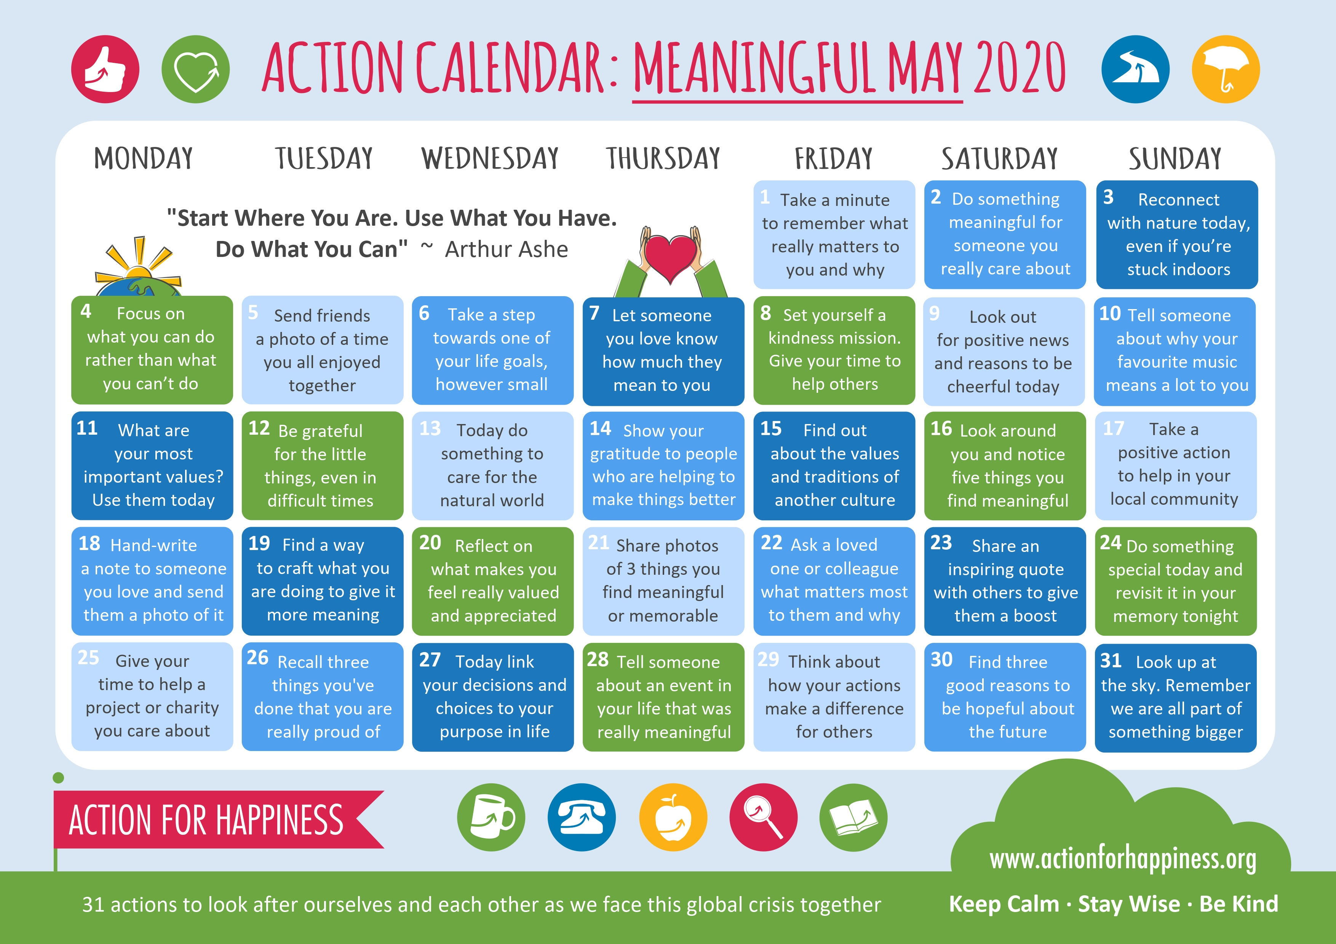

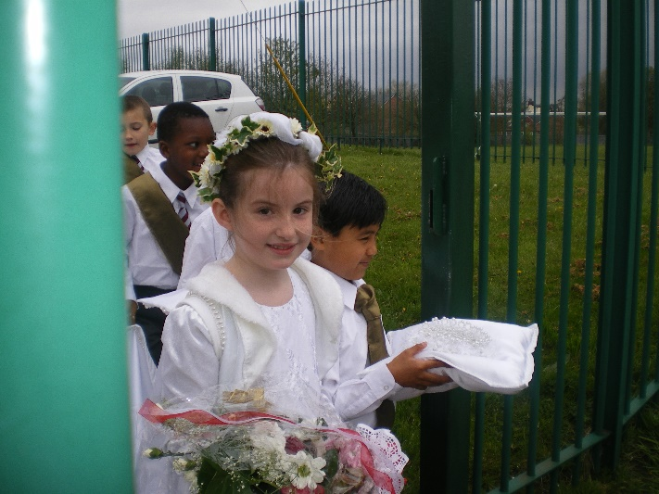

**May is the Month of Mary (My very young Caitlyn being the May Queen)**

Friday 1st May 2020

Dear Children, Parents, and Carers,

**SUMMER TERM**

Wow this is a very strange start to the last term. I hope you are all staying well and safe at home. Life as we knew it has changed. Although school has been open during the Easter break and continues to be open, it is not school as you know it either, if you have been following on Twitter the children attending have been doing activities very similar to those many of you have been doing that you have shared on Twitter.

Your teachers are phoning you all to check you are ok and if there is anything you need, but also just to hear your voices. Some of the teachers can’t be in school at the moment so they are ringing from home on their personal phones.

We know you are all finding it very hard to do any school work without being in school, we understand…it was all exciting at the beginning and the weather was lovely, but now the novelty has worn off and you are missing your friends, playground, staff, and many more things. So we want you to be able to communicate with your teachers and each other.

Initially Mrs Quigg is setting you all up with your school email account. This email will only work with your teacher and each other and I want you to remember any emails must be using kind words. The email address cannot be shared as a personal account.

Next she is working on setting you all up on Google Classroom, this is going to take some time. This is where any ideas for activities will be published and you can share work with your friends and your teachers. **Any work ideas or activities are not compulsory, but will keep your brains working and hopefully stop some of the boredom (my Caitlyn is very bored).**

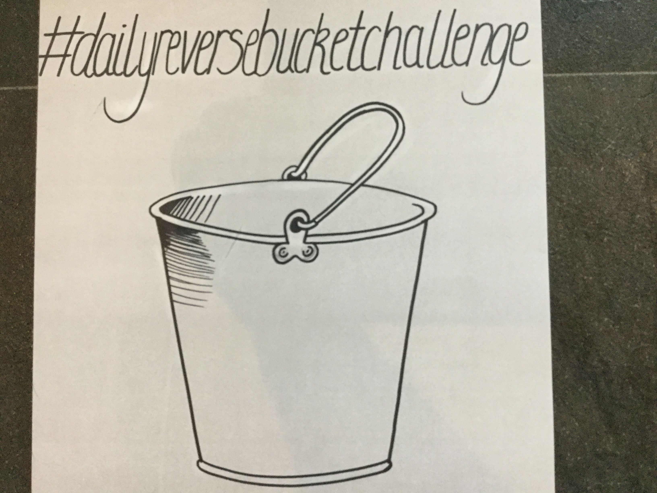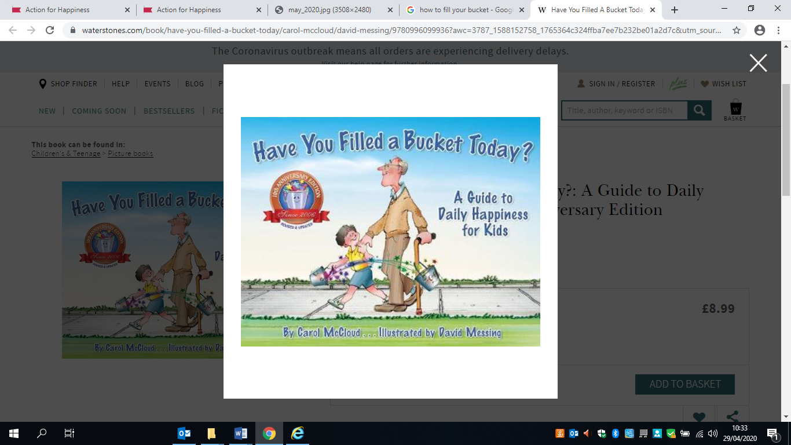Many of you know one of my favourite stories is “Have you filled your bucket Today?” I know that it is very hard at the moment and I am feeling it too, so I have started doing #DailyReverseBucketChallenge each day I fill it with things I have done.

**Key worker Care Provision**

We will not be open Friday 8th May as this is a Bank Holiday. Also if lockdown continues we will not be open Monday 25th May as this is also a Bank Holiday.

**New Reception and Nursery (September 2020)**

The new parents will be contacted by Miss Barran soon with information about starting school. Unfortunately the usual process of information meetings and visits to school cannot be planned for during this time.

**Coronavirus Update**

Unfortunately I have no indication about when school will reopen and in what format this will happen. There is a lot of different speculation happening in the press, but we still have no caretaker and a number of staff are not able to be in school. So I will be guided by government advice and discussions with our Governing Body. We have not made any decisions on classes or arrangements for returning until we have an indication about what this will look like. We will keep you informed as soon as we know anything.

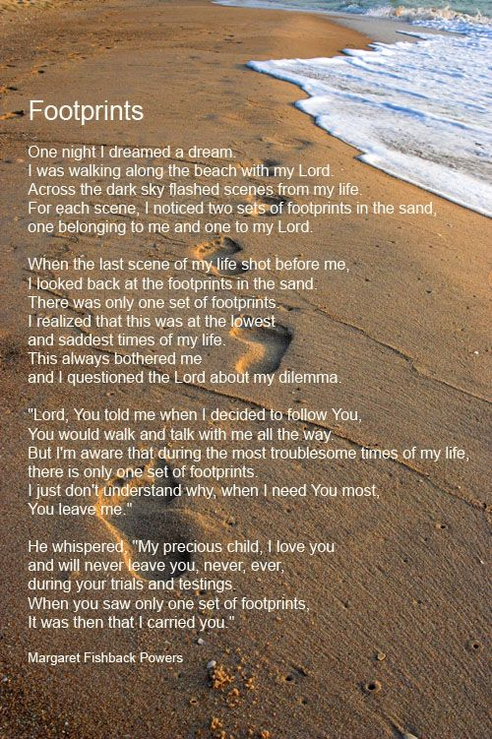The staff are in the process of writing a report to share with you regarding your child’s progress up to when we closed in March. It will look different to last year’s end of year report due to the nature of this year. Once completed I will write to you again. We are going to email these to parents, so please ensure your email address has been shared with the office [Office@stthomasmorerc.rochdale.sch.uk](mailto:Office@stthomasmorerc.roachdale.sch.uk)

At this difficult time I have regularly turned to my favourite poem…

Please #StaySafe and look after each other.

Best wishes,

Mrs J Butterworth

(Headteacher)