Lower Key Stage Two Home Learning
Dear Parents,
With all the concerns over coronavirus outbreak and how this might impact your child’s learning, we wanted to offer you some ideas to help you continue their education during any potential school closures.
Please use this book to complete any written activities or share photos of practical activities completed at home.
Spellings- practice spellings previously sent home this year as well as words from the year 3/4 spelling list found at the back of the homework diaries
Reading – Please encourage your child to read each day and fill in their homework diaries. Children can read on their own or read to an adult, you could ask your child to retell what they have read or ask them questions about this.
Login to Read Theory using your username and password
Maths – Times Table Rock Stars for 15 minutes per day.
Hit the button website
Writing – To write some exciting stories, diary entries, reports, recounts or poems remembering to include accurate punctuation, powerful adjectives and any other Boomtastics, Fantastics and Grammaristics. We will look forward to reading these.
Topic – see separate topic task
Science – write a report on a living creature and their habitat.
Useful websites:
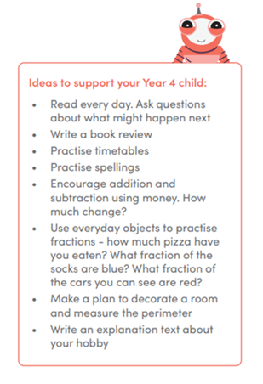
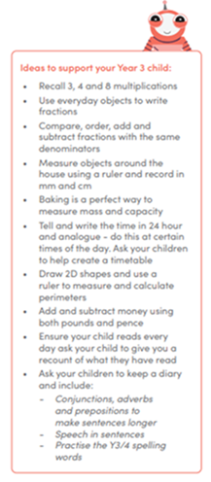
Below are list of useful websites that have created FREE home learning packs during this time. Please take a look and complete a variety of activities with your child.
Classroom secrets - https://classroomsecrets.co.uk
For this website children will have their own log in so that they are able to play the interactive games for maths, grammar, spellings and reading.
Twinkl – www.twinkl.co.uk/offer and enter the code – UKTWINKHELPS
White Rose Maths – https://whiterosemaths.com/ resource available from 20/03/2020
Hit the button maths - https://www.topmarks.co.uk/maths-games/hit-the-button

