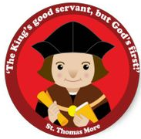
Key Stage One Home Learning
Dear Parents,
With all the concerns over coronavirus outbreak and how this might impact your child’s learning, we wanted to offer you some ideas to help you continue their education during any potential school closures.
Please use this book to complete any written activities or share photos of practical activities completed at home.
Year 1 – Please go over phonic sounds in the packs that have previously been sent home.
Year 2 – Please begin to complete some of the Special Agent Training pack materials. (Orange folders)
Spellings- practise common exception words previously given or you can find them at the back of your child’s reading record. Please practise reading and writing them and possibly using them within sentences.
Reading – Please continue to read with your child each night for at least 15 minutes. Ask your child questions about what they have read, write sentences about the text. Please note this as usual in your child’s reading record.
Maths – complete Big Maths CLIC sheets if not already done so. Use the websites below to complete activities.
Writing – information sheets about animals, write a diary entry, independent stories, comprehension questions based on the books they have read. We will look forward to reading your work
Useful websites:
Below are list of useful websites that have created FREE home learning packs during this time. Please take a look and complete a variety of activities with your child.
Oxford owl (phonics) – interactive phonic games
Classroom secrets - https://classroomsecrets.co.uk/free-home-learning-packs/
Classroom secrets kids – kids.classroomsecrets.co.uk/
Twinkl – www.twinkl.co.uk/offer and enter the code – UKTWINKHELPS
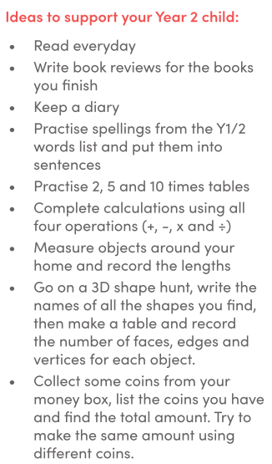
White Rose Maths – https://whiterosemaths.com/ resources available from 20/03/2020
