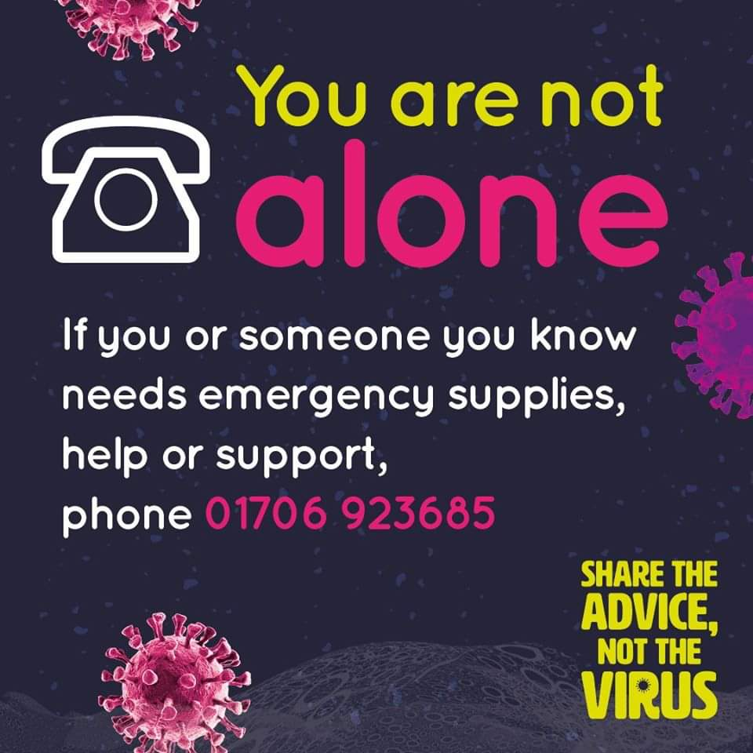

Rochdale Council have set up community response hubs across the borough and are delivering emergency food parcels to households.

Please ring the special hotline number if you’re a vulnerable resident or know of a vulnerable resident that requires food supplies, or any other help and support: **01706 923685**

For more information follow the link below:

<http://www.rochdale.gov.uk/coronavirus>