ST. URSULA’S CATHOLIC

PRIMARY SCHOOL

Diocese of Brentwood



Straight Road, Romford, Essex, RM3 7JS

*EYFS/KS1 Tel:* 01708 345200 *KS2 Tel:* 01708 343170

*EYFS/KS1 E-mail*: head@stursulasinf.havering.sch.uk

*KS2 E-mail*: [office@st-ursulas-rc-jun.havering.sch.uk](mailto:office@st-ursulas-rc-jun.havering.sch.uk)

*Website:* https://stursulascatholicfederation.co.uk/

Headteacher: Mr K. Ashburn

With God at the heart of our St Ursula’s family, we welcome all as we learn and grow together

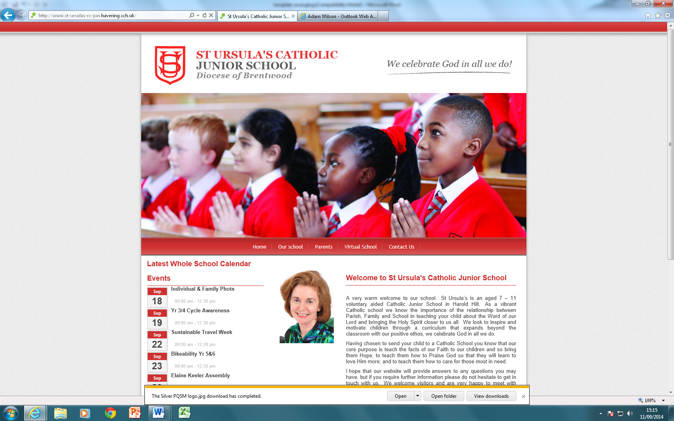

**Isolation work pack**

Dear Parent/Carers,

We must ensure that our pupils are still accessing curriculum work even when they are self-isolating. The information below will detail the tasks set for your child by her/his teacher. These tasks are linked to the work being completed in your child’s class this week. This will ensure your child does not miss out on the skills being taught.

Our topic in Nursery for this week is ‘**Starting School?’**

Prepare your child for starting Reception, talk to them about following things.

* What would you do in the morning before going to school?

How are you feeling about going to school?

What are you looking forward to do when you go to Reception?

Is there anything you are unsure or worried about?

* Can you talk to a grown up about the meeting new children and how you can make new friends when you go to Reception.
* Talk about their time in Nursery

What was their favorite toy in Nursery?

What did they like doing the best in the Nursery?

Who did they like playing with?

What would they miss the most?

In addition, you can do following activities with your child at home.

**Cutting**- children can practice cutting pictures out of old magazines or catalogues which will help strengthen their hand muscles.

**Matching number to sets**- you can write the number and ask the child to find the correct amount of objects to match with the number. E.g 2 socks to match with number two. 3 pcs of legos to match with number 3.

**Number counting**- the child can help you count different things at home, e.g. they can help you count the plates as you set the dinner table, they can count the steps while walking up the stairs.

**Number formation**- children can practice writing early numbers.

**Shape hunt**- Children can find different shapes within the environment, e. g. they can find square shape in the window or a circle shape pancakes.

**Shape tracing-** you can help your child draw different 2D shapes i.e. Circle, square, triangle & rectangle

**Pencil control**- you can encourage children to hold pencil or white board pen in a tripod grip when they are drawing or mark making. Here is the instruction to support your child to use a tripod grip.



**Physical Development:**

Please take this time to help develop your children’s turn taking skills. Play turn taking games like snap or snake and ladders where they have to wait for their turn.

Self-care skills- Encourage children to dress/undress independently and to use tissues to blow their own noses.

We have talked a lot about having to wash hands carefully and for a good length of time so that the germs are washed away, so reinforce the same at home.

**Reading**

These are the books we are focusing on in Nursery, but sharing any book with your children is an essential part of children’s development. You can talk about characters in the book, how the story is going to end, and their favourite part of the story.

**Our ‘Books to Love’ are listed below**.

If you have any of these books at home, please read them to your child. You could also use the following links to listen to the story:

Duck in the Truck <https://www.youtube.com/watch?v=pICm8MigUQI>

Each Peach Pear Plum <https://www.youtube.com/watch?v=Oyt50ZoM3G8>

Where’s my Teddy? <https://www.youtube.com/watch?v=535aeHPS1J4>

Dear Zoo <https://www.youtube.com/watch?v=ZqGYWRHOV6E>

The very hungry Caterpillar <https://www.youtube.com/watch?v=75NQK-Sm1YY>

Owl Babies <https://www.youtube.com/watch?v=2KmH-1zcGe8>

Farmer Duck <https://www.youtube.com/watch?v=qaPrR_IWmog>

So Much <https://www.youtube.com/watch?v=c1M4ucJytQQ>

Five Minute Peace <https://www.youtube.com/watch?v=EA3blQB1psU>

We’re Going on a Bear Hunt <https://www.youtube.com/watch?v=-d1_Z068z74>

Additionally encourage children to sing different nursery rhymes and songs whenever they can. Some of the songs we have learnt in Nursery are listed below

Old Mc Donald had a farm

The wheels on the bus go round and round

Incy wincy spider

Twinkle twinkle little star

If you happy and you know it

Head shoulders knees and toes

Many Thanks

Mrs Shah