**A Level Business**

**Bridging Unit**

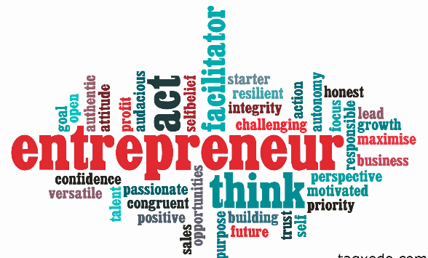

**Year 11 - 12**

**2022**

**Name**

**Task 1: Fact file**

**Produce a fact file on an entrepreneur of your choice. You should do this on a PC.**

**You could include information such as:**



**Name**

**Background**

**Businesses Owned**

**Business Sector they operate in**

**Skills and qualities**

**Personal characteristics**

**Leadership style**

**Task 2: Planning A new enterprise**

**A successful entrepreneur needs to understand the market, have determination, passion, and resilience and be able to take and cope with risk.**

Outline A New Business Idea you could possibly start: Think of the type of business e.g. sole trader, concept, purpose and suitable name.

How would you plan to expand in the future?

Any other ideas to note?

What would your sources of finance be?

How would you research the market?

**Task 3: Extended Writing( Choose your level)**

**Blue Challenge**

**Explain one advantage to an entrepreneur of your choice of being able to take risks. (4)**

**Purple Challenge**

**Assess two of the most important characteristics of an entrepreneur.**

**Pink Challenge (8)**

**Pink Challenge**

**Thinking about your new enterprise idea in task 2, evaluate the benefits and drawbacks to you personally of starting that business. (20)**

**__________________________________________________________________________________________________________________________________________________________________________________________________________________________________________________________________________________________________________________________________________________________________________________________________________________________________________________________________________________________________________________________________________________________________________________________________________________________________________________________________________________________________________________________________________________________________________________________________________________________________________________________________________________________________________**

**Task 4: Barriers to entrepreneurship.**

**One barrier to entrepreneurship is lack of finance. Carry out research and find more examples of barriers. Present your findings in a though shower below.**

Barriers

To

Enterprise

**Task 5: Entrepreneur motives**

People start businesses for many different reasons. These are known as entrepreneur motives

Entrepreneur motives can be broken down into financial and non-financial motives.

Complete the table below to show a range of both types of motives. The first one has been done for you.

|  |  |
| --- | --- |
| **Financial Motives** | **Non-financial Motives** |
| **Profit maximisation – some entrepreneurs start a business to make a profit** | **Independence – some entrepreneurs wish to have their own independence and work at a time convenient to them to fit around their lifestyles** |
|  |  |
|  |  |

**Task 6: Types of Ownership**

**Complete the table below to show examples of ownership types and their relevant advantages and disadvantages to the business.**

|  |  |  |  |
| --- | --- | --- | --- |
| **Type of Business** | **An example** | **Advantages** | **Disadvantages** |
| **Sole Trader** |  |  |  |
| **Partnership** |  |  |  |
| **Private Limited Company** |  |  |  |
| **Public Limited Company** |  |  |  |
| **Franchise** |  |  |  |
| **Social Enterprise** |  |  |  |

**Task 7: Branding**

**Explain one business that you believe has a good brand. Fully justify your reasons. You may use this space to add or draw suitable images.**

**Task 8: You and The Future**

Please tell me a little bit about yourself and what you would like to do in your future career. Then on the last page create your own CV or bring along a copy of your current CV in September.

**Curriculum Vitae**